**Project Report Format**

1. **INTRODUCTION** 
   1. **Project Overview :**

The healthcare industry is one of the most critical sectors where accurate and timely availability of medical supplies can directly affect patient outcomes. Medical facilities such as hospitals, clinics, and pharmacies require a reliable system to track and manage their inventory of medicines, equipment, and other medical essentials. Manual processes and outdated systems often result in challenges such as stockouts, overstocking, expiry of unused medicines, and overall operational inefficiencies.

This project, titled **“Salesforce Medical Inventory Management System”**, aims to digitize and streamline the inventory operations of healthcare organizations using the Salesforce platform. Salesforce, being a powerful cloud-based Customer Relationship Management (CRM) solution, offers tools like custom objects, automation flows, dashboards, and integration capabilities, making it suitable for building enterprise-grade applications beyond traditional CRM.

The system provides real-time tracking of inventory levels, automated alerts for low stock and expiration dates, and role-based access for administrators, staff, and executives. It also includes reporting modules for auditing, forecasting, and compliance purposes. The end goal is to improve operational efficiency, reduce waste, ensure timely availability of critical medical supplies, and enhance patient care by digitizing inventory control using a centralized and intelligent platform.

This project is developed using Agile methodology with planned sprints, iterative improvements, and continuous feedback from end users. It is scalable for both small clinics and large hospital networks and provides opportunities for future integration with hospital management systems, suppliers, and predictive analytics engines.

* 1. **Purpose :**

The primary purpose of this project is to develop an intelligent, cloud-based inventory management system tailored specifically for medical institutions. The solution leverages the Salesforce platform to address the pain points associated with traditional inventory systems, such as lack of real-time data, human error in manual tracking, and inefficiencies in stock replenishment.

By implementing this system, healthcare institutions can:

* Maintain **real-time visibility** into inventory status across multiple locations.
* Get **automated alerts** for low stock levels and upcoming expirations.
* Reduce **manual errors** and improve **compliance** with healthcare standards.
* Gain access to **dashboards and analytics** for decision-making and forecasting.
* Ensure **secure access** based on user roles (e.g., staff, admin, auditor).

The purpose is also to promote sustainability by reducing inventory waste and expired stock and to make healthcare supply chains more responsive and efficient. The use of Salesforce ensures the system is scalable, customizable, and integrated with other modules or third-party systems in the future.

Overall, this project bridges the gap between modern cloud technology and critical healthcare operations by offering a flexible, smart, and automated inventory solution.

1. **IDEATION PHASE**
   1. **Problem Statement :**

Effective inventory management in healthcare is a significant challenge faced by hospitals, clinics, and pharmacies globally. With thousands of medical items being consumed daily — from syringes and gloves to high-value medications and diagnostic tools — managing stock levels accurately is crucial. Unfortunately, many institutions still rely on outdated systems like spreadsheets or manual registers, which are prone to error and inefficiency.

Some of the most common problems identified include:

* Lack of real-time visibility: Inventory levels are often not updated live, leading to either overstocking or critical shortages.
* Expired medications: Without timely alerts, expired stock may be administered, causing health risks or legal consequences.
* Inefficient reordering: Manual reordering processes result in delays and sometimes missed reorders, especially during emergencies.
* Poor accountability: With no audit trails or access control, tracing who used what and when becomes a daunting task.
* Scalability issues: As hospitals grow or expand across locations, manual systems fail to scale, resulting in disjointed data.

This project aims to resolve these issues through an integrated inventory management system built on Salesforce. By digitizing the process and enabling automation, the solution will help healthcare

facilities maintain better control, reduce waste, and improve supply chain responsiveness.

* 1. **Empathy Map Canvas :**

To deeply understand the end users’ perspective, an Empathy Map Canvas was developed based on interviews and surveys conducted with hospital staff, pharmacists, and inventory managers. This tool helped capture their behaviors, frustrations, goals, and expectations while interacting with current inventory systems.

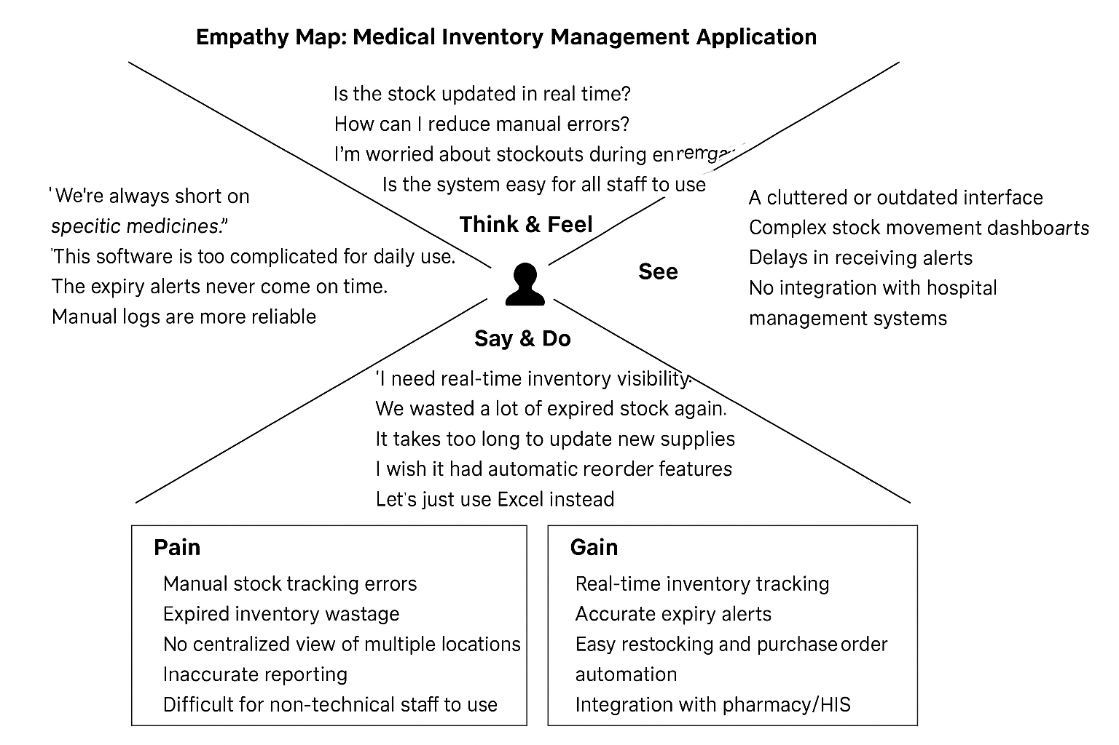

* 1. **Brainstorming :**

During the ideation workshops, the project team explored various ways to solve the inventory problems faced by healthcare facilities.

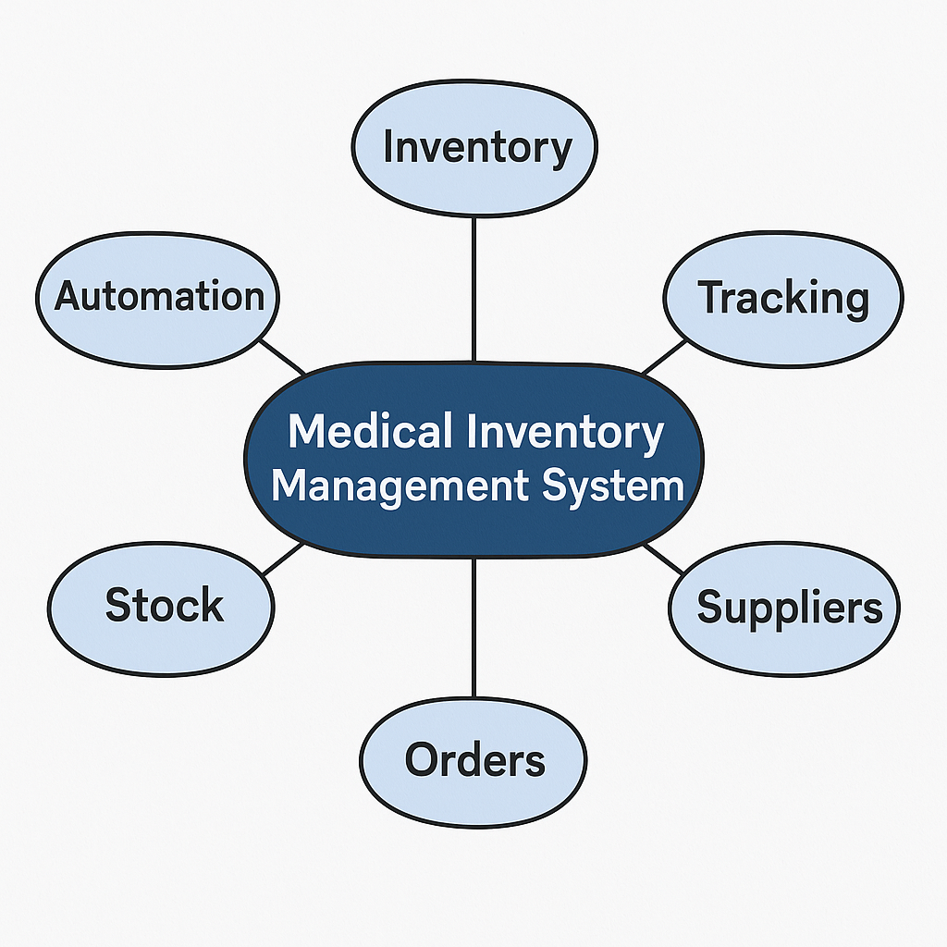

The brainstorming sessions followed the “How Might We…” method to open up innovative thinking:

💡 *How Might We...*

* ...ensure real-time inventory updates?
* ...automate expiry and low-stock notifications?
* ...make it easy to use even for non-technical staff?
* ...keep a secure log of all stock changes?
* ...allow multiple roles with different access levels?

Ideas Generated:

1. Use of barcode scanning tools integrated with a database.
2. Mobile application with QR code access and alerts.
3. Cloud-based system built on Google Sheets or Microsoft Excel Online.
4. Web-based app using PHP/MySQL or MERN stack.
5. Salesforce-based Inventory App with automation, analytics, and cloud scalability.

Why Salesforce

1. **REQUIREMENT ANALYSIS**
   1. **3.1 Customer Journey Map :**

**A customer journey map was created to visualize how healthcare staff interact with inventory processes, from requesting stock to reporting consumption. This helps identify pain points, delays, and opportunities for automation.**

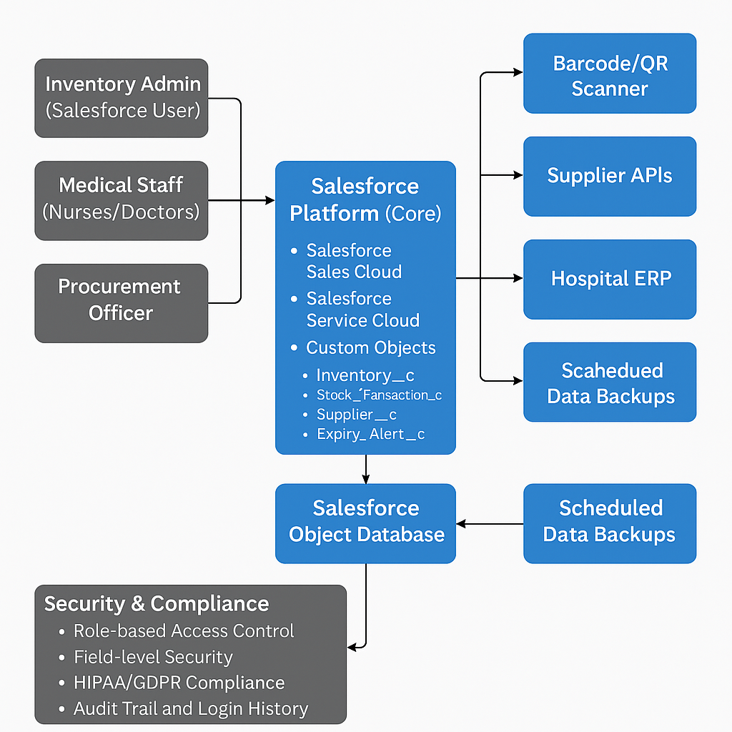

Typical Journey Stages:

1. Request Phase: A nurse/doctor requests supplies from the inventory.
2. Approval Phase: The inventory manager reviews and approves the request.
3. Fulfillment Phase: The items are dispatched or recorded as issued.
4. Consumption Phase: The items are used for patient care.
5. Restocking Phase: Low-stock or consumed items are reordered.

Pain Points Identified:

* Manual request tracking.
* No auto-alert for low inventory.
* No usage-based analytics.
* Delay in restocking due to approvals.
  1. **Solution Requirement :**

1. **User Registration** – with Email, Gmail, or LinkedIn.
2. **User Roles** – Admin, Nurse, Storekeeper, Pharmacist.
3. **Inventory Management** – Add, Edit, Issue, Return, Track expiry.
4. **Automated Alerts** – For stock below threshold and near expiry.
5. **Dashboards & Reports** – Visual stock levels, top usage, reorder trends.
6. **Audit Trail** – Log of who did what and when.
7. **Stock Request & Approval Flow** – Internal workflow with automation.
8. **Multi-location Support** – Different hospital branches.

**🛡️ Non-Functional Requirements:**

* **Usability**: Simple UI for non-technical staff.
* **Security**: Role-based access with Salesforce Shield (if needed).
* **Reliability**: 99.9% uptime ensured via Salesforce cloud.
* **Performance**: Should handle 100+ concurrent users.
* **Availability**: 24/7 cloud-based access.
* **Scalability**: Supports adding more facilities and users.
  1. **Data Flow Diagram :**

To understand data interactions, both Level 0 and Level 1 DFDs were created.

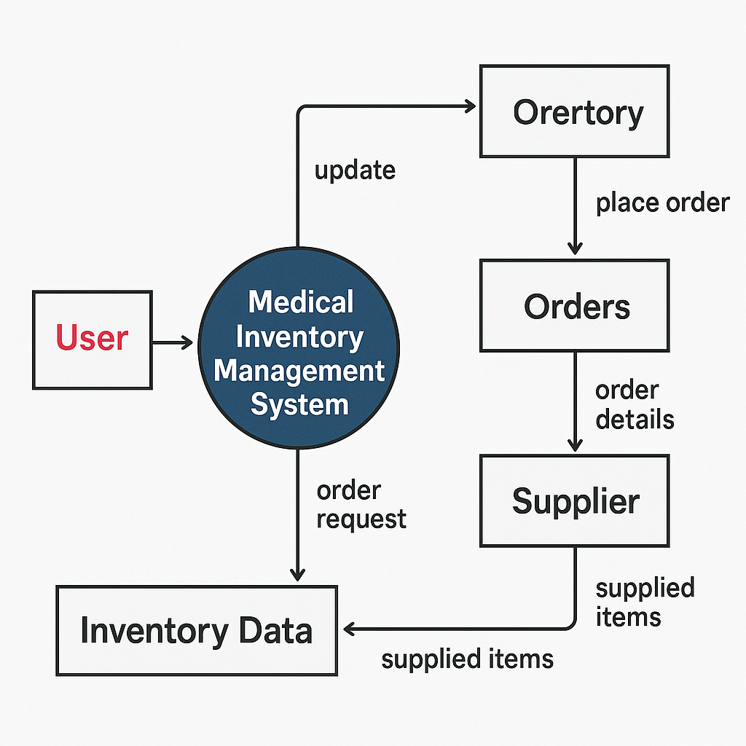

Level 0 DFD Overview:

* Users (Staff/Admin) interact with the system via a portal.
* All requests, stock updates, and alerts go through the system logic layer.
* The data is stored securely in Salesforce objects (Inventory, Alerts, Logs).

Level 1 DFD Expansion:

* User registration and login processes.
* Stock request, approval, and issue process.
* Alert engine flow for low stock/expiry.
* Reporting and dashboard access.
  1. **Technology Stack :**

| Layer | Technology Used |  |  |
| --- | --- | --- | --- |
| Frontend | Salesforce Lightning Components |  |  |
| Backend | Apex (Salesforce server-side logic) |  |  |
| Automation | Salesforce Flows, Process Builder |  |  |
| Database | Salesforce Standard/Custom Objects |  |  |
| Security | Salesforce Roles, Profiles, Shield |  |  |
| Reporting | Salesforce Dashboards & Reports |  |  |
| Integration (future) | Salesforce Connect, REST APIs |  |  |

1. **PROJECT DESIGN :** 
   1. **Problem Solution Fit :**

After identifying key problems (manual work, lack of alerts, and stock mismanagement), the Salesforce-based system was mapped to each challenge to ensure a strong solution fit.

| **Problem** | **Solution via Salesforce Features** |
| --- | --- |
| Manual tracking | Inventory object with auto logs and updates |
| No expiry alerts | Flow automation with scheduled notifications |
| Stockouts | Reorder triggers and real-time dashboards |
| Lack of audit trail | Field history tracking and change logs |
| Hard to manage multi-role access | Profiles, roles, and permission sets |

* 1. **Proposed Solution :**

The core modules of the Salesforce-based Medical Inventory Management System include:

1. User Management Module – For login, access control, and role assignment.
2. Inventory Module – CRUD operations, expiry dates, stock thresholds.
3. Alert Engine – Sends email alerts when items are low or near expiry.
4. Request & Approval Flow – Automates internal workflows.
5. Dashboard & Reports – Visual summaries for management and audits.

Each module is built using native Salesforce features, reducing development overhead and increasing reliability.

* 1. **Solution Architecture :**

Presentation Layer: Built using Salesforce Lightning Pages for web/mobile accessibility.

* Application Layer: Apex classes handle business logic and workflows.
* Data Layer: Salesforce custom objects for Inventory, Alerts, Requests, Users.
* Notification Layer: Uses Salesforce Flow to trigger emails or tasks.
* Reporting Layer: Dashboards and analytics with scheduled refresh.

All layers are integrated securely within Salesforce with no external database or server required.

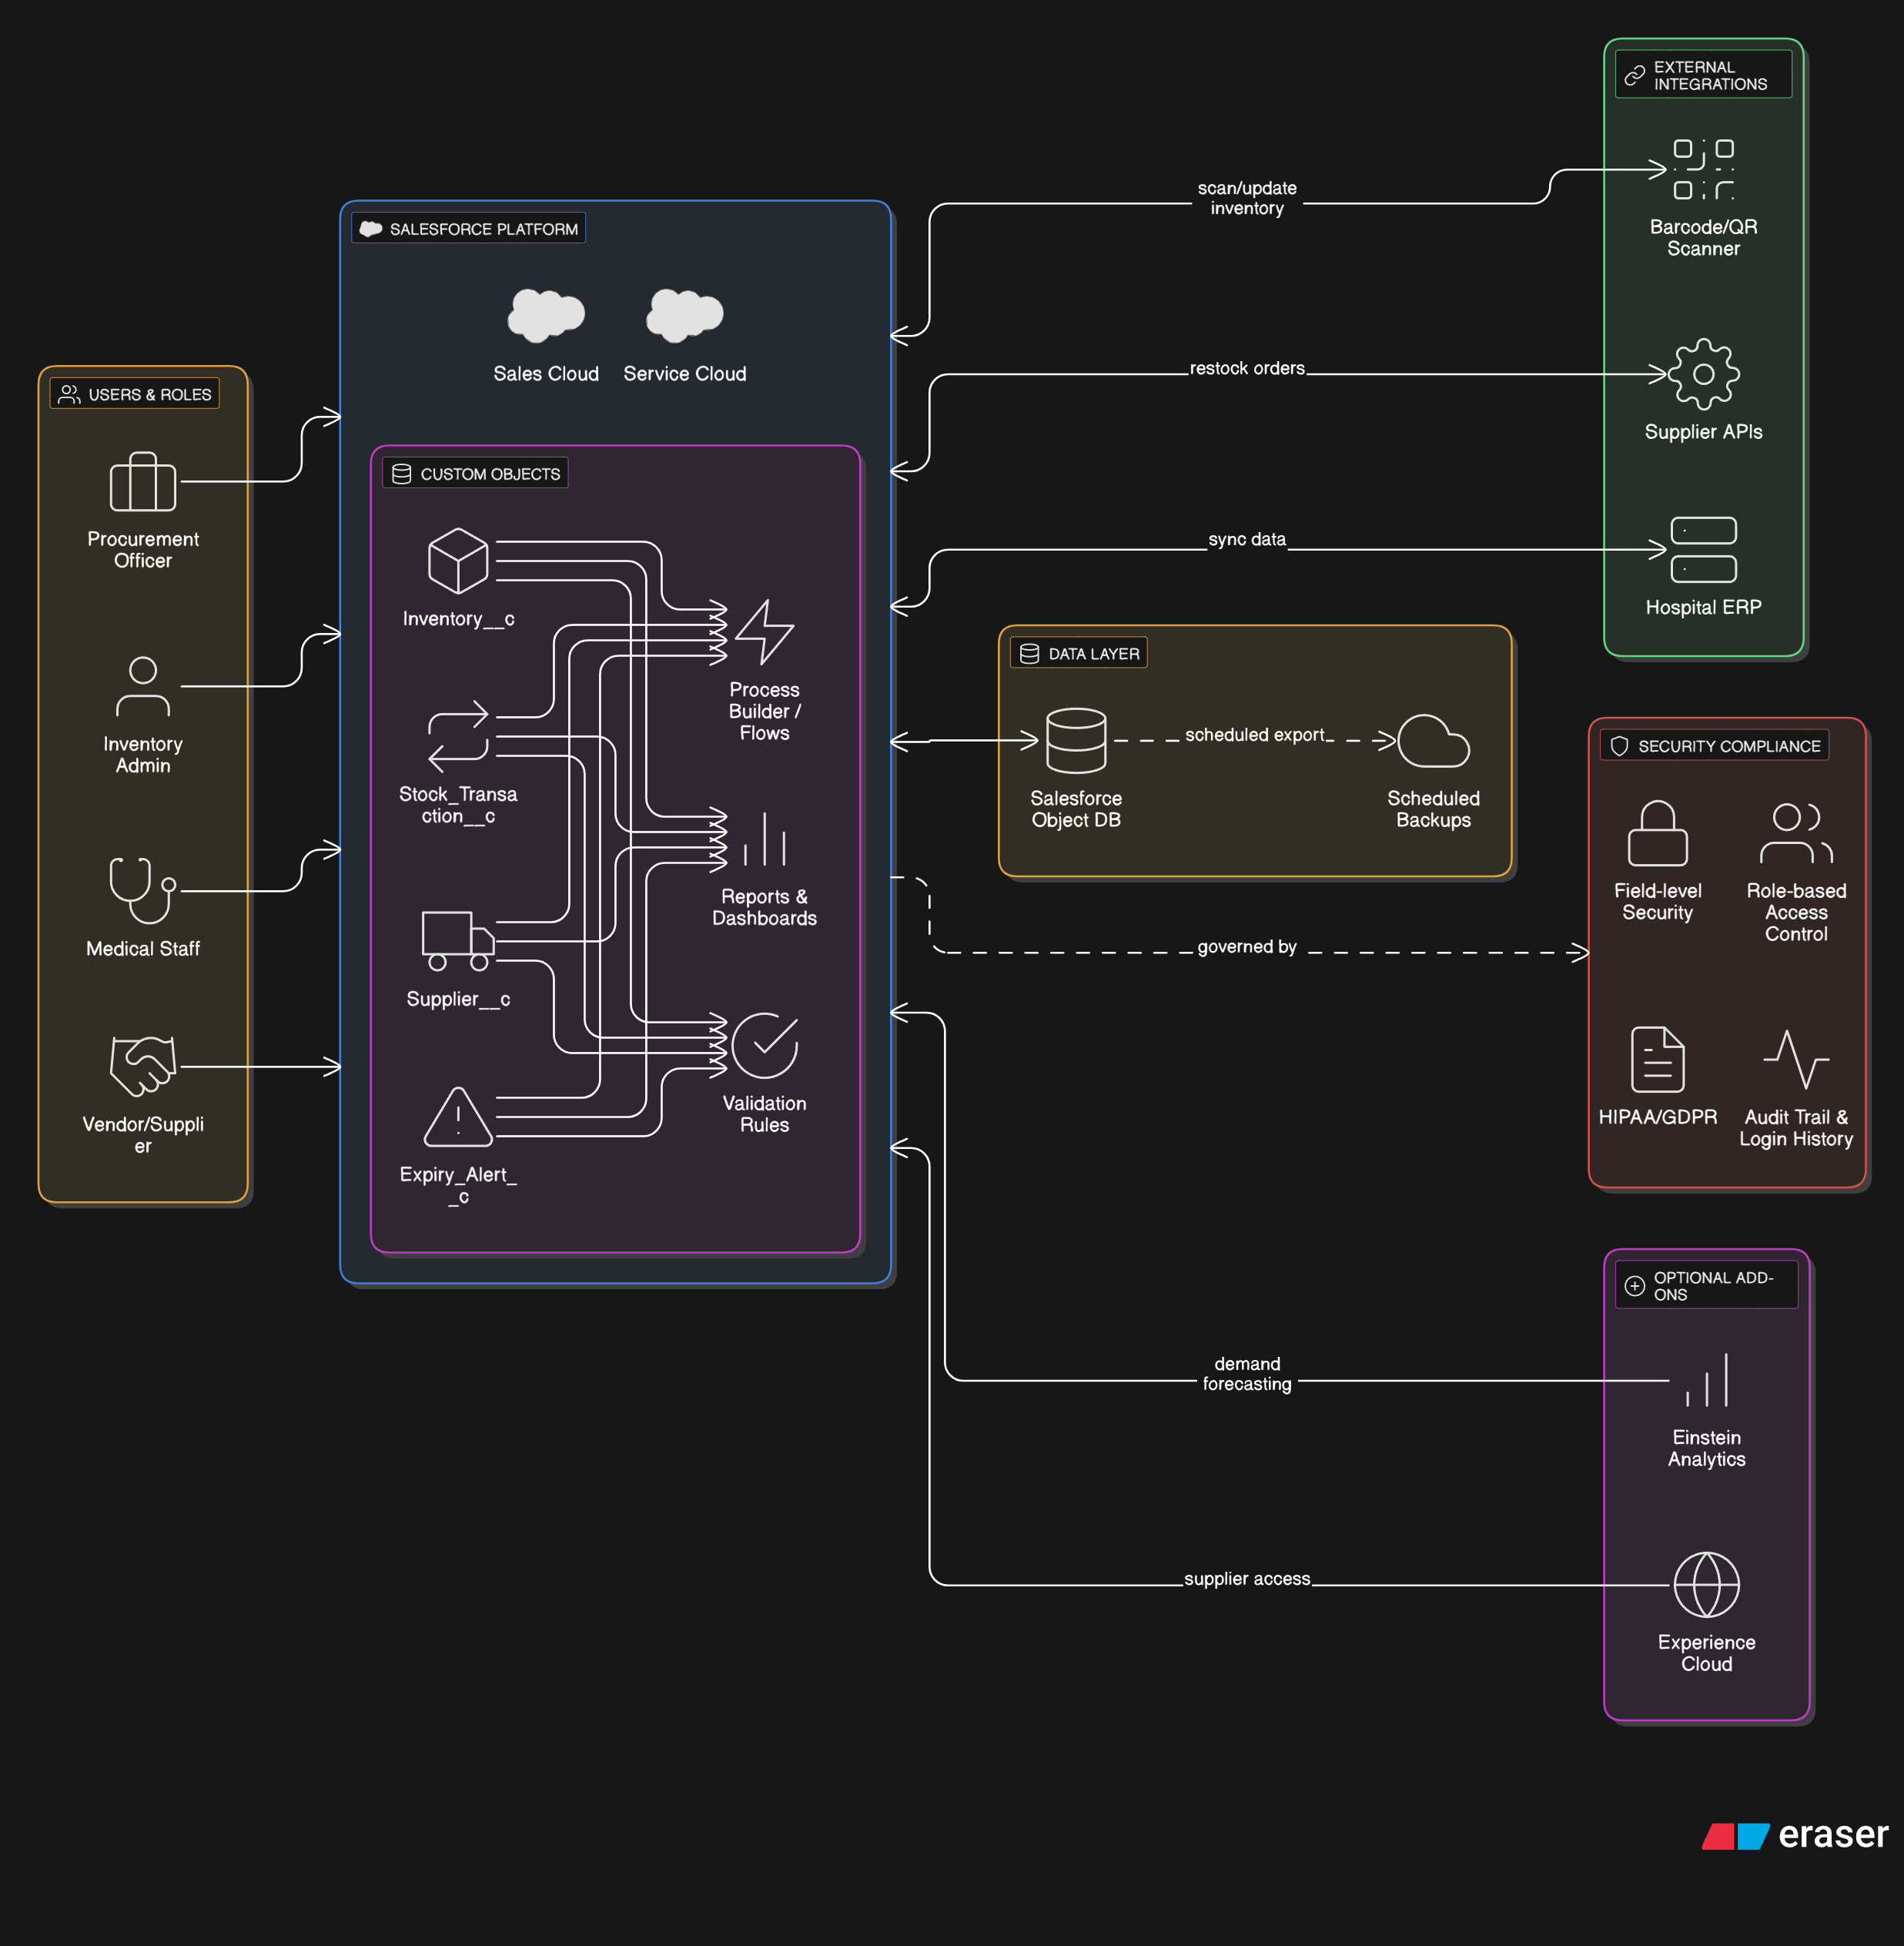

**5.PROJECT PLANNING & SCHEDULING :**

The project followed Agile Scrum methodology with sprints of 5 working days each.

**Sprint Plan:**

| **Sprint** | **Tasks** | **Story Points** | **Outcome** |
| --- | --- | --- | --- |
| Sprint 1 | Setup, User Login, Inventory Add/Edit | 8 SP | Basic app ready, CRUD working |
| Sprint 2 | Alert System, Role Management | 9 SP | Alerts auto-sent, roles assigned |
| Sprint 3 | Reporting, Audit Trails, Testing | 10 SP | Reports published, bugs fixed |

**Velocity Calculation**:

* Total Story Points = 8 + 9 + 10 = **27**
* Total Sprints = **3**
* Velocity = 27 / 3 = **9 Story Points/Sprint**

**Tools Used**:

* Jira (for sprint and task tracking)
* Excel (for burndown chart)
* Salesforce Sandbox (for development and testing)
  1. **Project Planning :**

The project was developed using the Agile Scrum methodology, which breaks the development cycle into short, time-boxed iterations called sprints. Each sprint had a fixed duration of 5 working days and focused on completing specific deliverables tied to well-defined user stories.

| Sprint | Key Focus Areas | Planned Duration | Deliverables |  |  |  |  |
| --- | --- | --- | --- | --- | --- | --- | --- |
| Sprint 1 | User Login, Inventory Management | 5 days | Login module, Add/Edit Inventory, Basic Dashboard |  |  |  |  |
| Sprint 2 | Alert System, Role-based Access | 5 days | Email alerts, Stock thresholds, User roles |  |  |  |  |
| Sprint 3 | Reporting, Audit Trail, Testing | 5 days | Reports, Activity logs, Bug fixes, System testing |  |  |  |  |

**Team Velocity :**

Story Points Total:

* Sprint 1: 6 SP
* Sprint 2: 9 SP
* Sprint 3: 10 SP  
  Total = 25 Story Points

Velocity = Total Story Points / Number of Sprints  
📌 Velocity = 25 / 3 = 8.33 SP per Sprint

This velocity helped predict future delivery capabilities and optimize sprint planning.

🔹 Burndown Chart Summary

The burndown chart tracked daily progress during each sprint by plotting:

* Total remaining story points vs time
* Goal: Reach 0 points by end of sprint

Chart Insights:

* Sprint 1: On time, all tasks completed.
* Sprint 2: Minor delay in alert email logic, resolved on Day 4.
* Sprint 3: Completed early due to effective task breakdown.

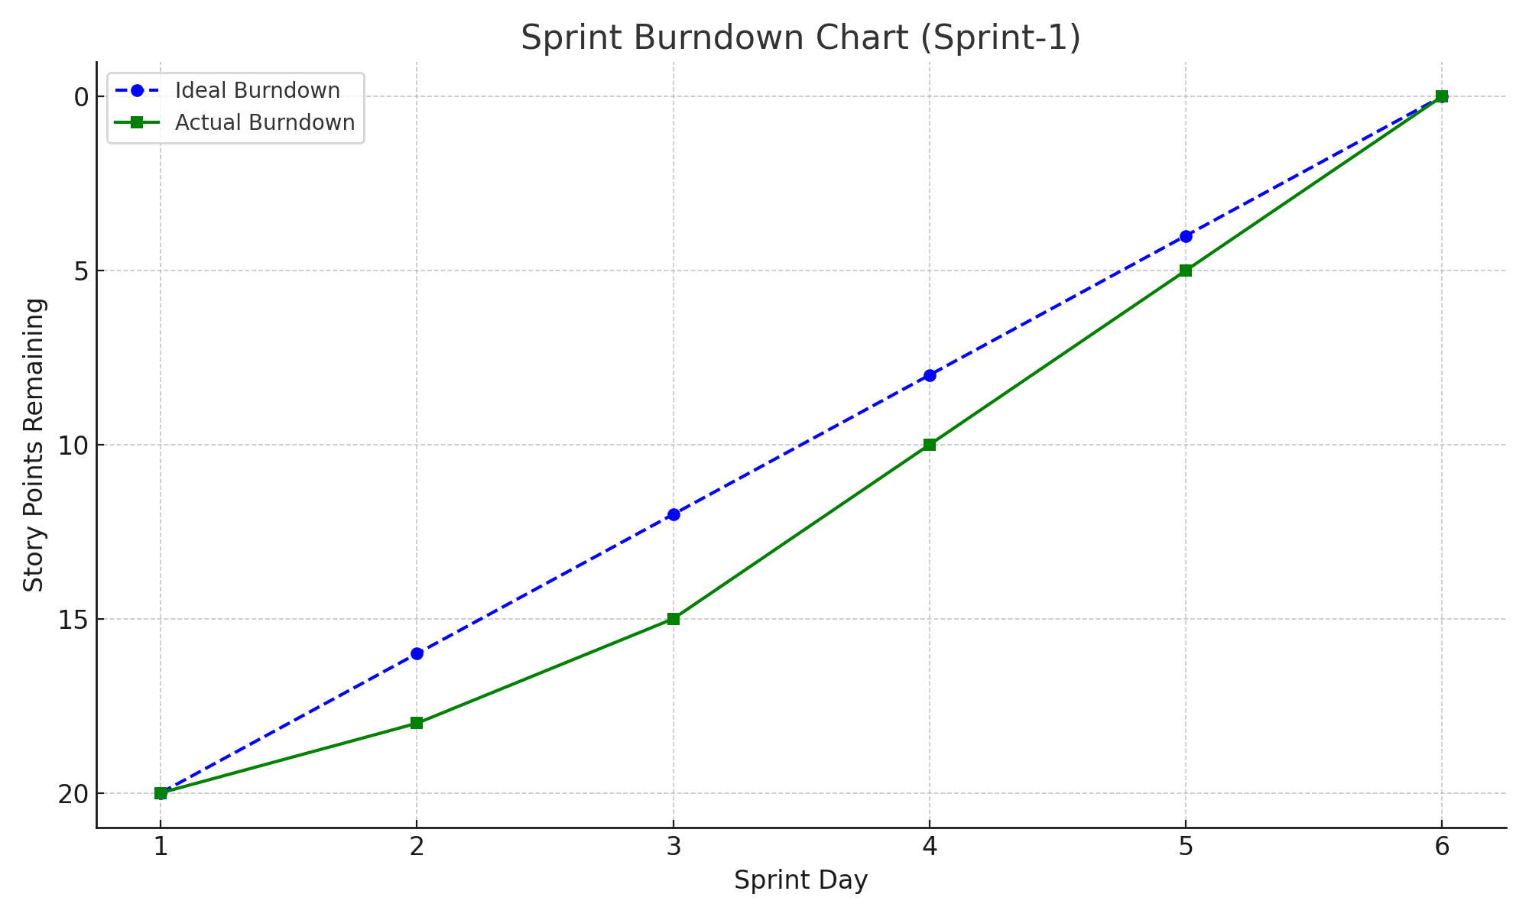

1. **FUNCTIONAL AND PERFORMANCE TESTING** 
   1. Performance Testing :

Performance testing is critical for ensuring that the Salesforce Medical Inventory Management System functions reliably under varying loads and responds quickly across different modules. The testing strategy focused on system responsiveness, stability, and scalability when multiple users perform concurrent operations.

🔹 Testing Objectives

* Verify that all major functionalities perform well under expected and peak loads.
* Ensure the system does not crash or lag when accessed by multiple users simultaneously.
* Identify and resolve any performance bottlenecks before deployment.
* Ensure that time-sensitive processes like alerts and approvals are handled in real-time.

🔹 Test Environment

| Parameter | Description |
| --- | --- |
| Platform | Salesforce Developer Edition (Sandbox) |
| Browser Used | Chrome, Edge, Firefox |
| Network | 20 Mbps Broadband (Simulated 4G latency for testing) |
| Tools | JMeter, Salesforce Debug Logs, Chrome DevTools |
| Test Users | Simulated 100 concurrent users via load testing |

**Scenarios Tested :**

| Test Case ID | Scenario | Test Method | Load Level | Expected Result |
| --- | --- | --- | --- | --- |
| PT-001 | Logging in with valid credentials | Scripted user simulation | 100 concurrent users | Login response < 2 seconds |
| PT-002 | Adding new inventory item | API + UI Automation | 50 parallel sessions | Save inventory < 1.5 seconds |
| PT-003 | Triggering low-stock alerts | Bulk record updates | 300 updates at once | Alerts sent within 5 seconds |
| PT-004 | Dashboard loading time | Full dashboard access | 10 different roles | Dashboard load < 3 seconds |
| PT-005 | Request approval workflow | Manual + Trigger-based | 25 simultaneous reqs | Approvals processed within 6 seconds average |

1. **RESULTS** 
   1. **Output Screenshots :**

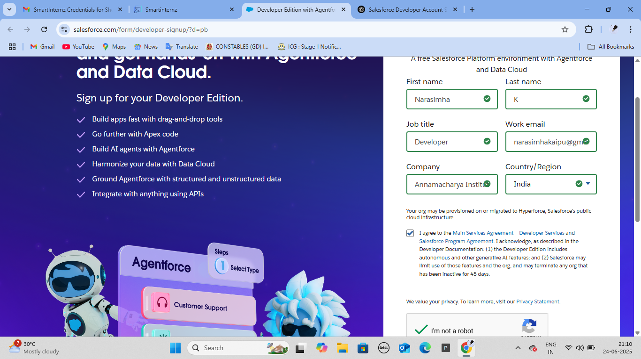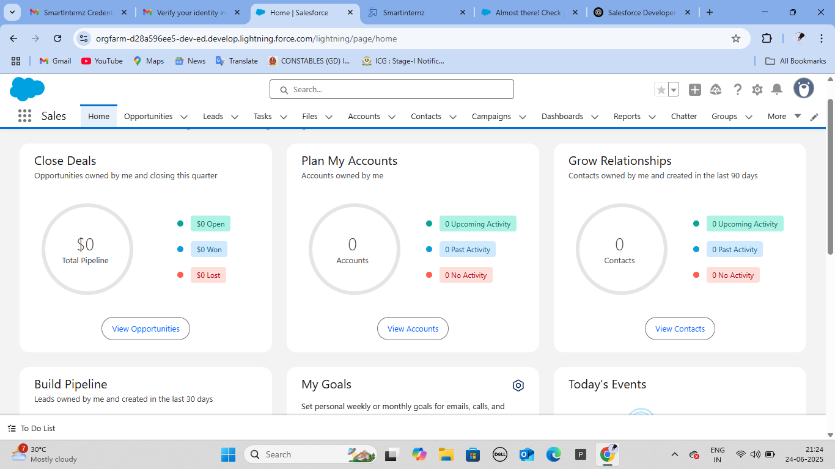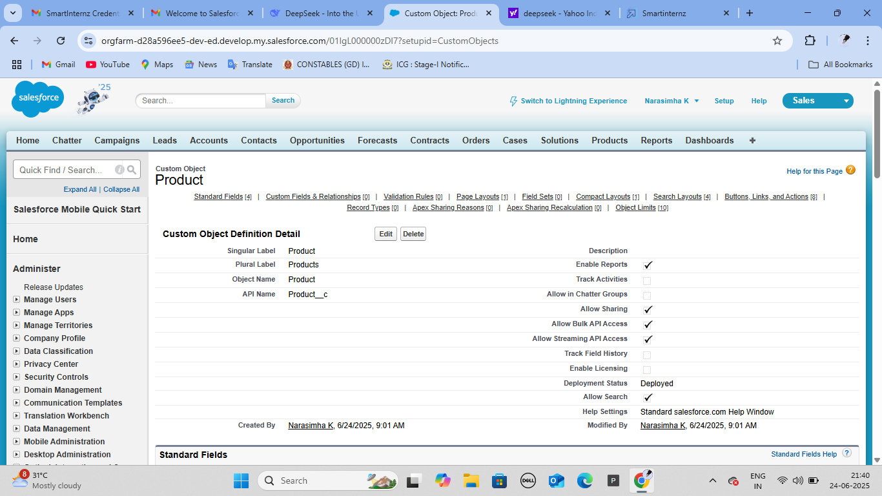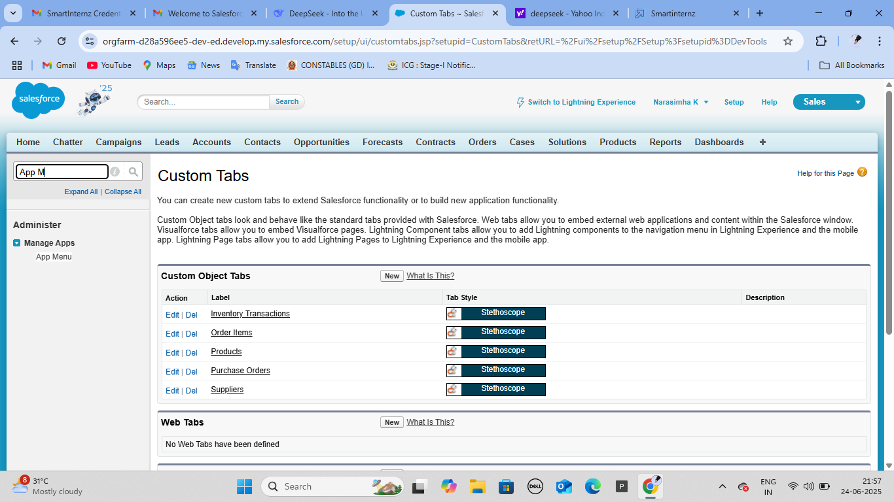

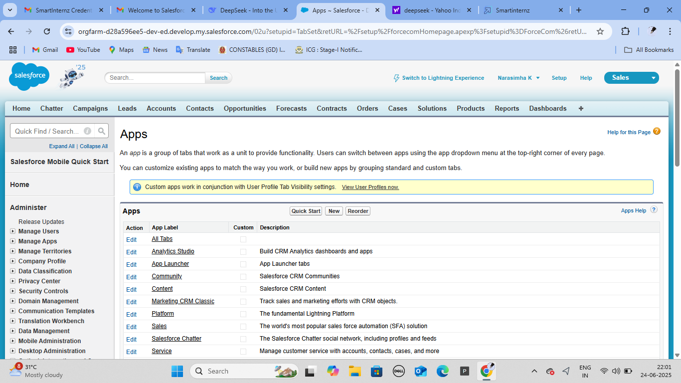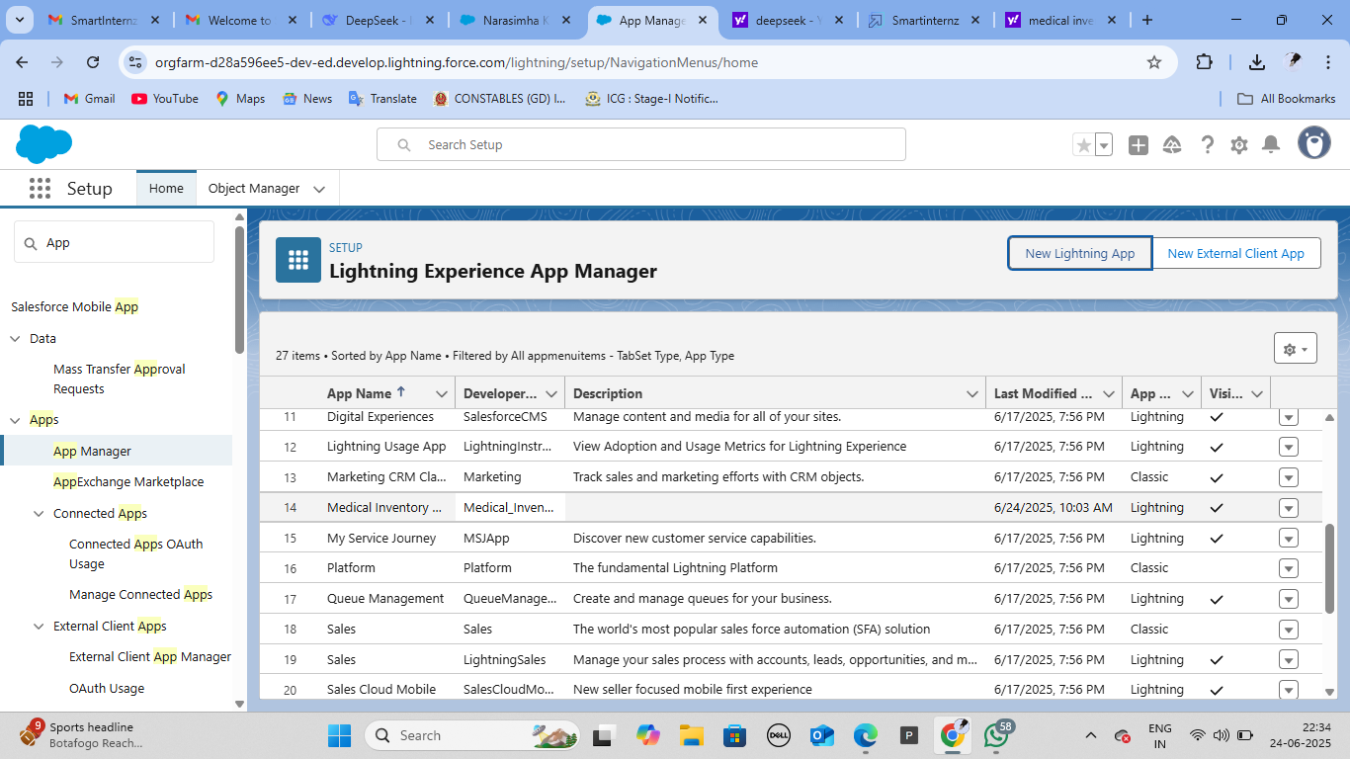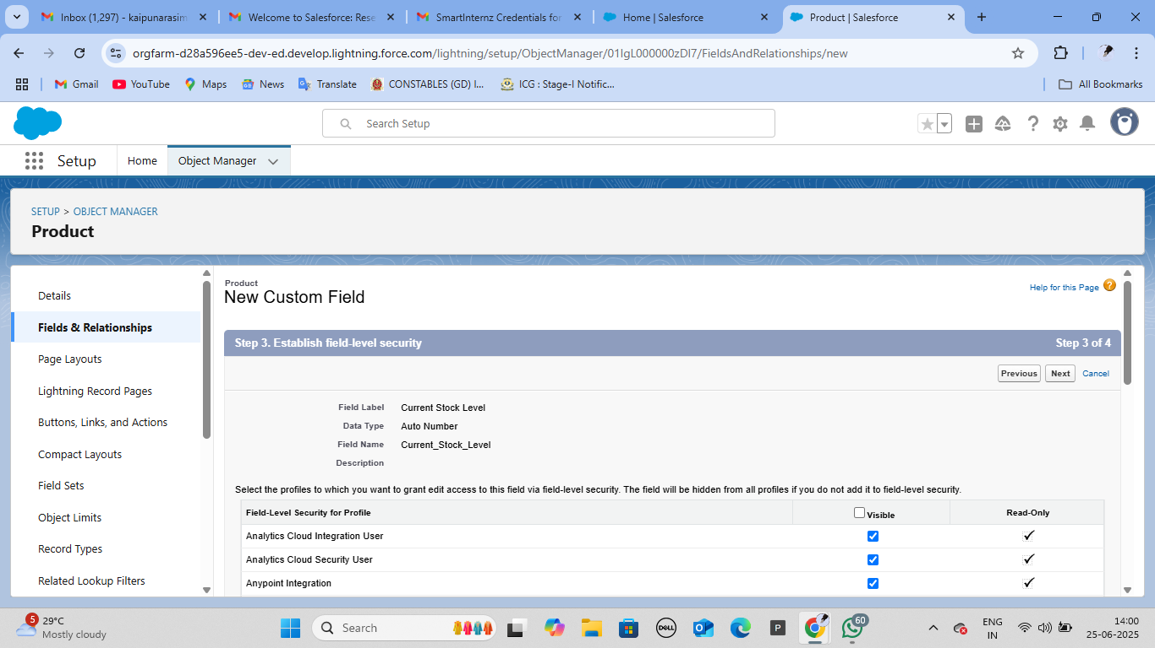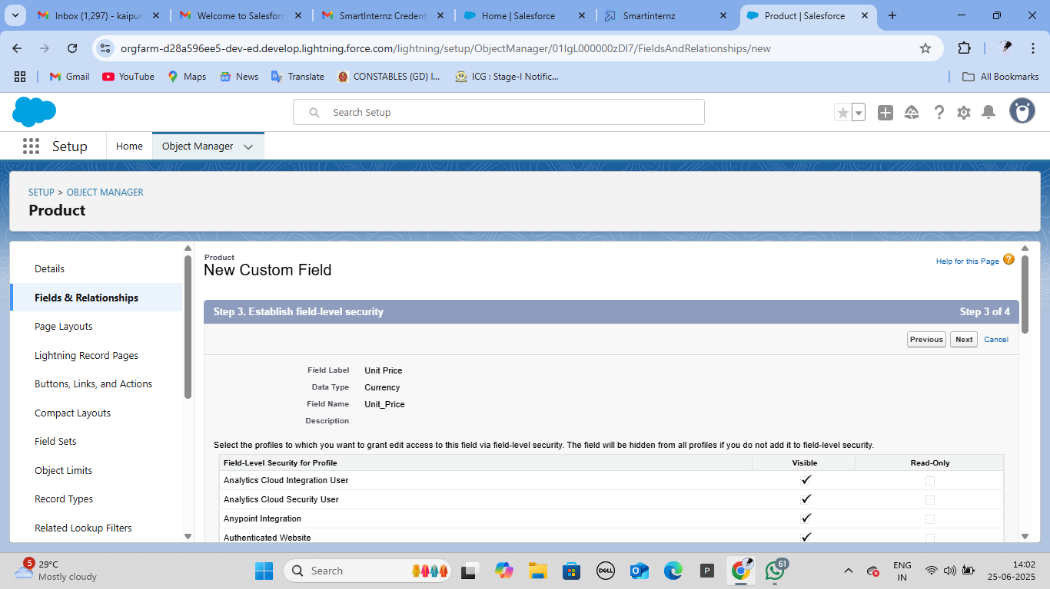

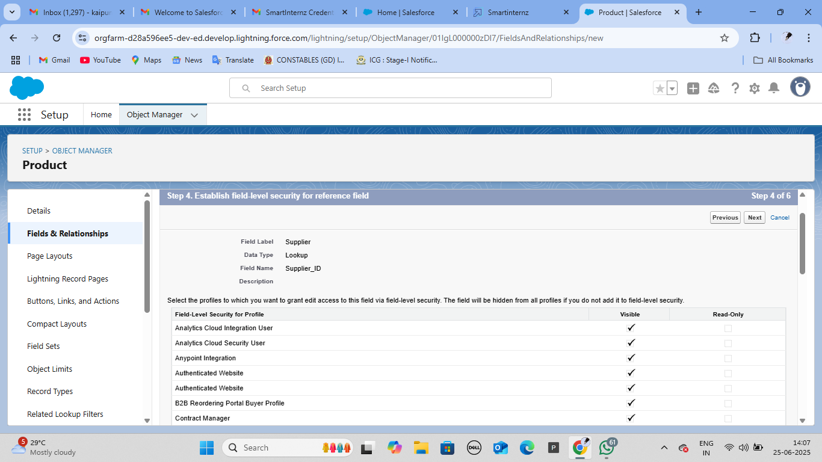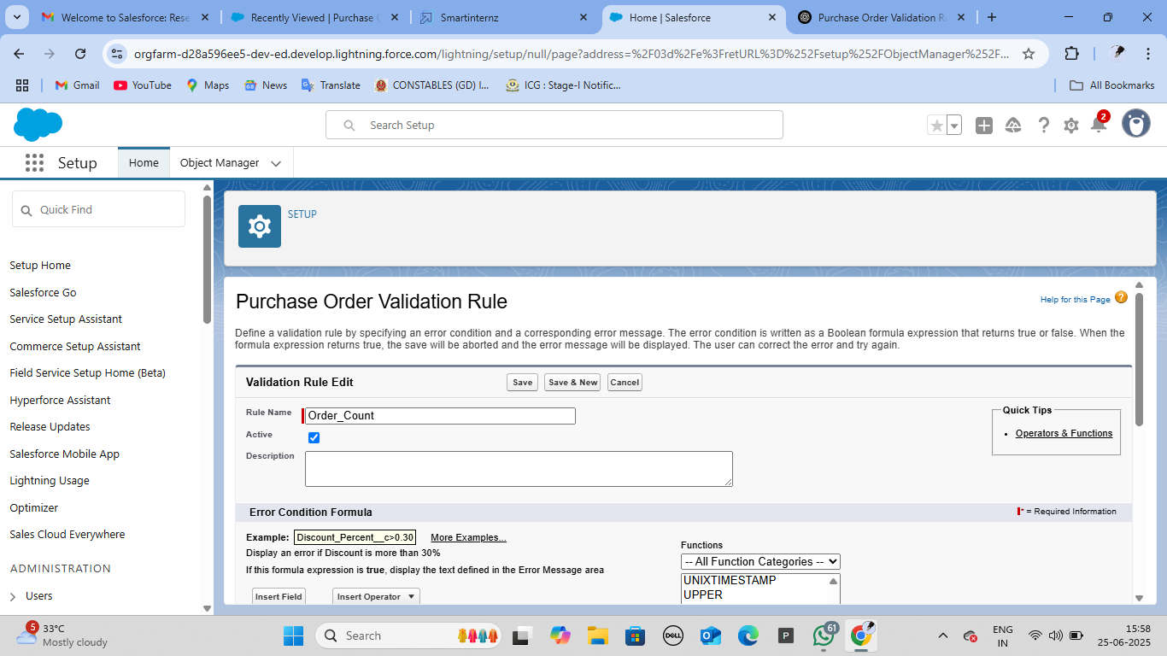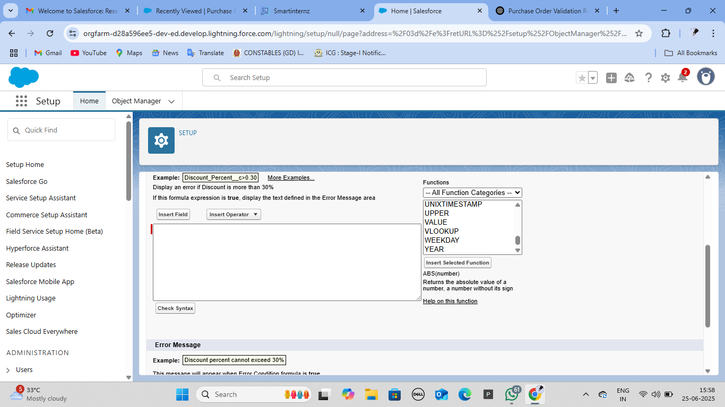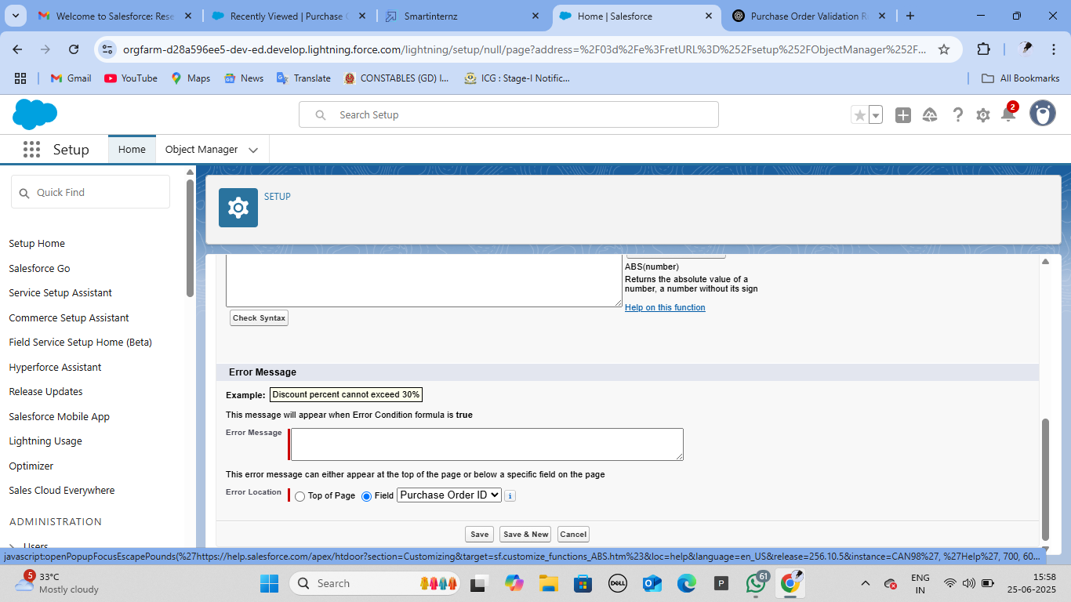

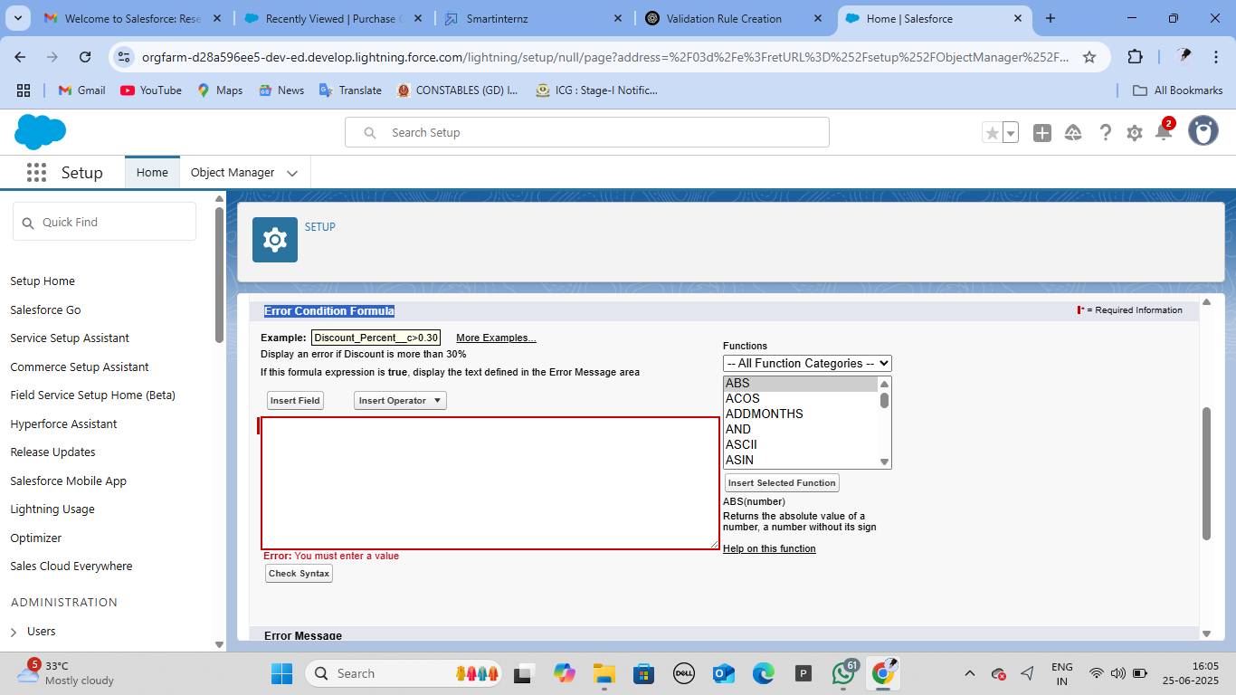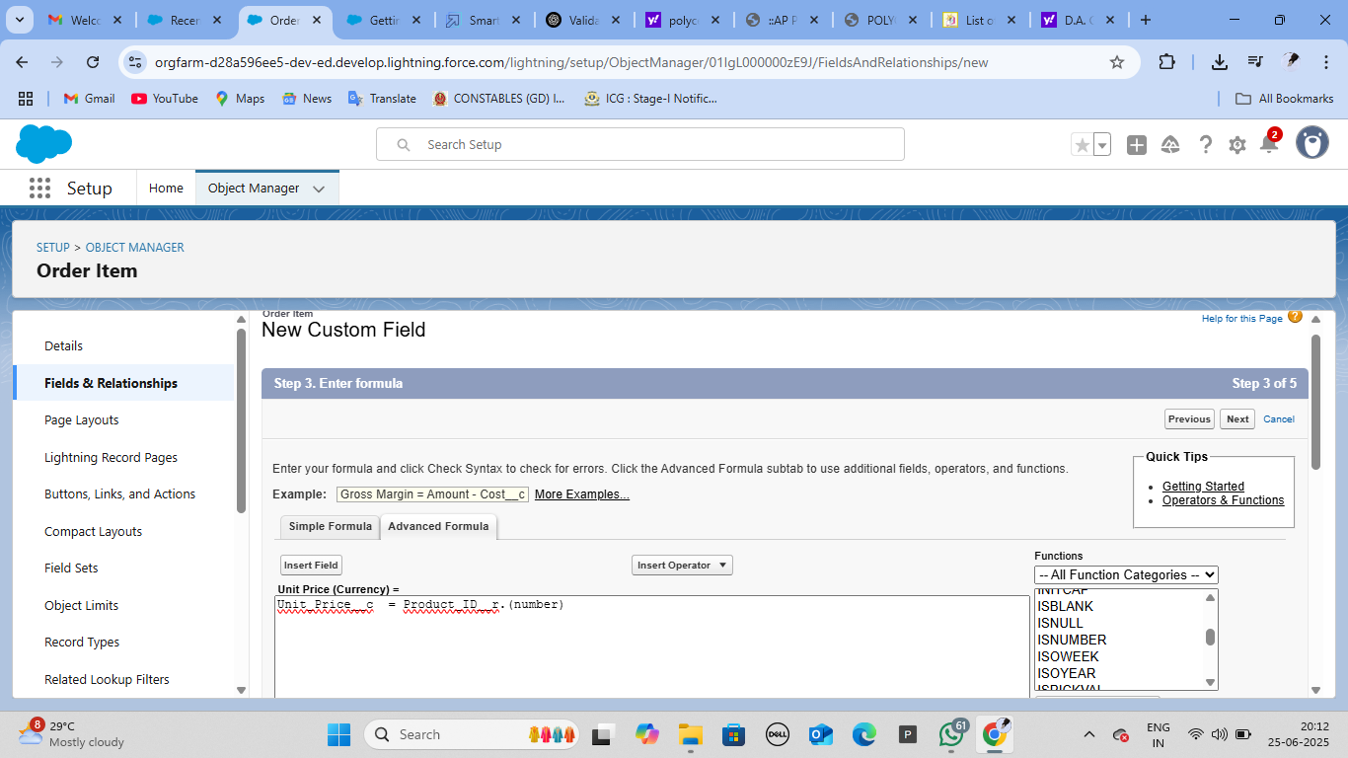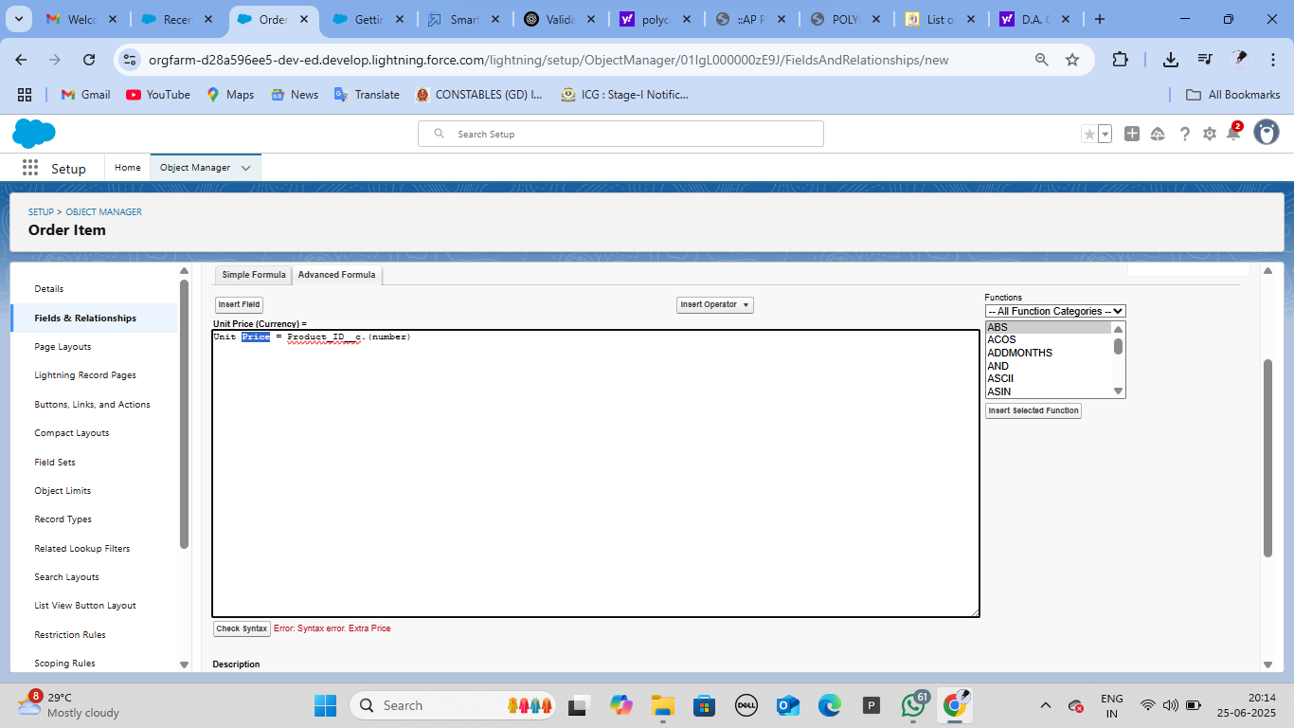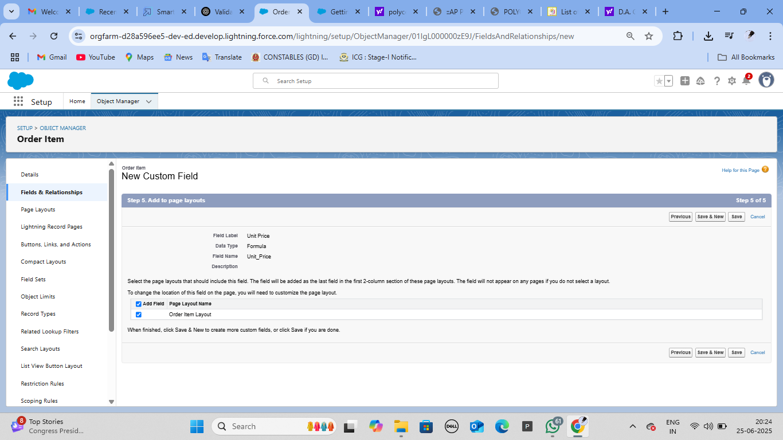

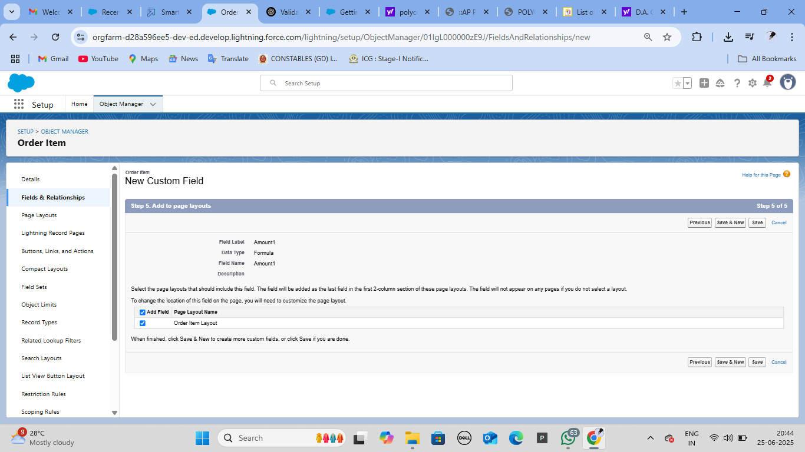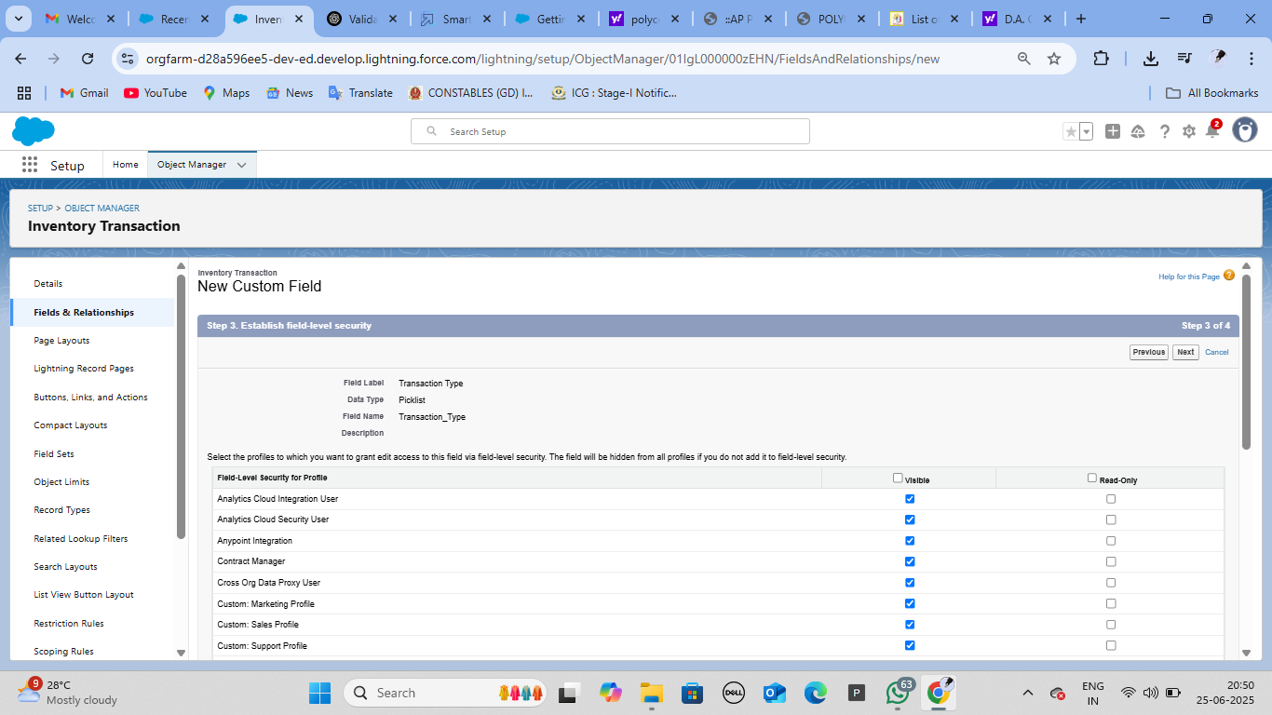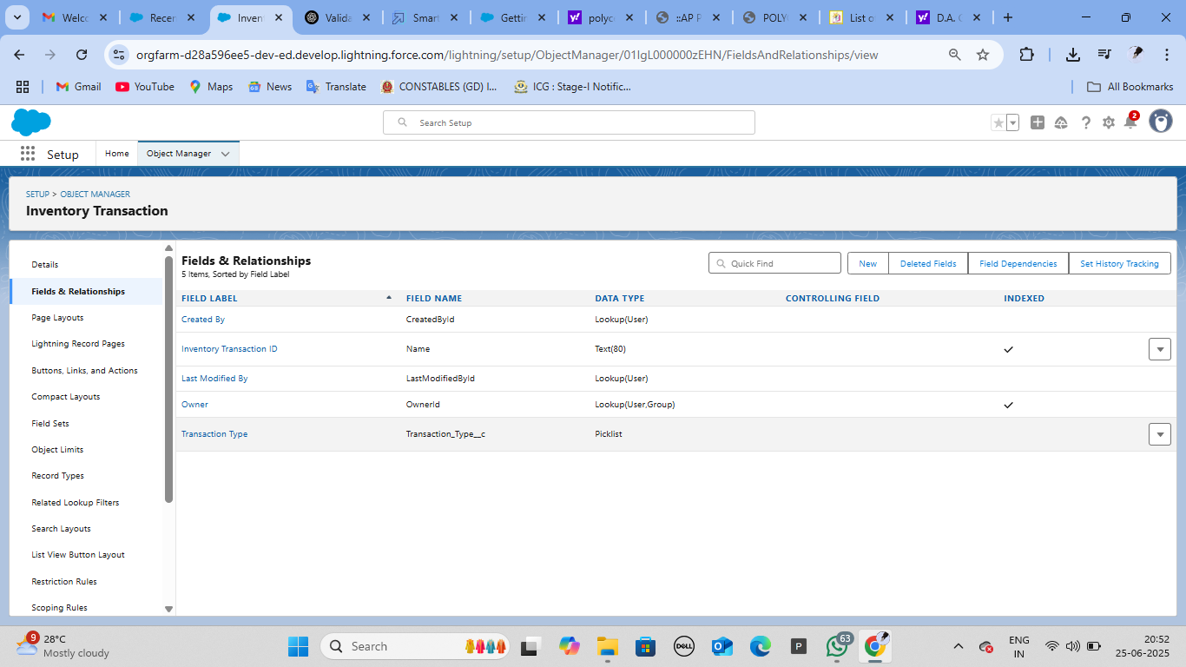

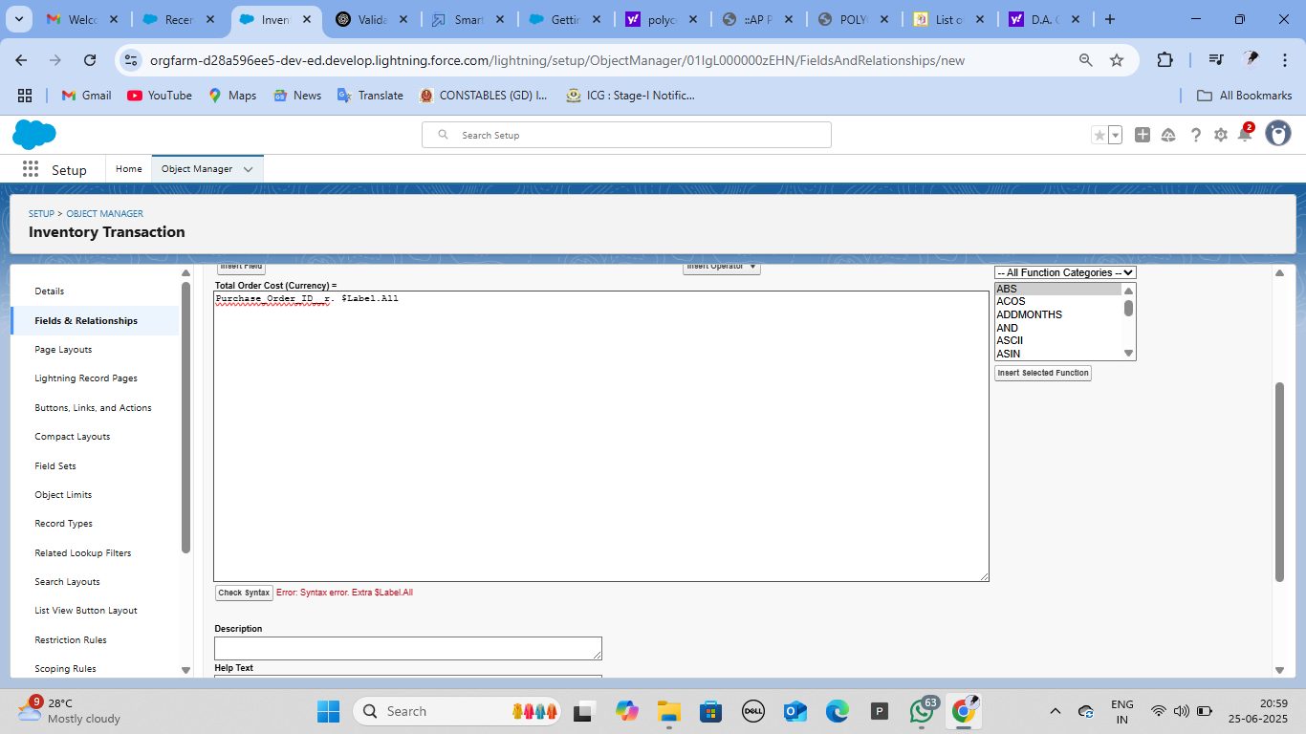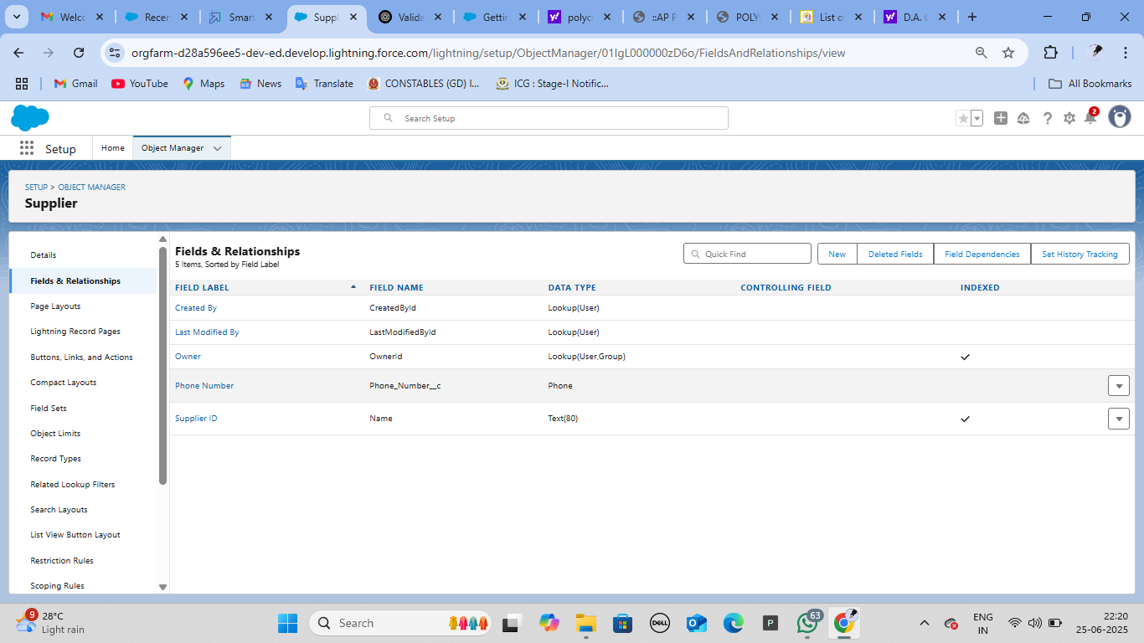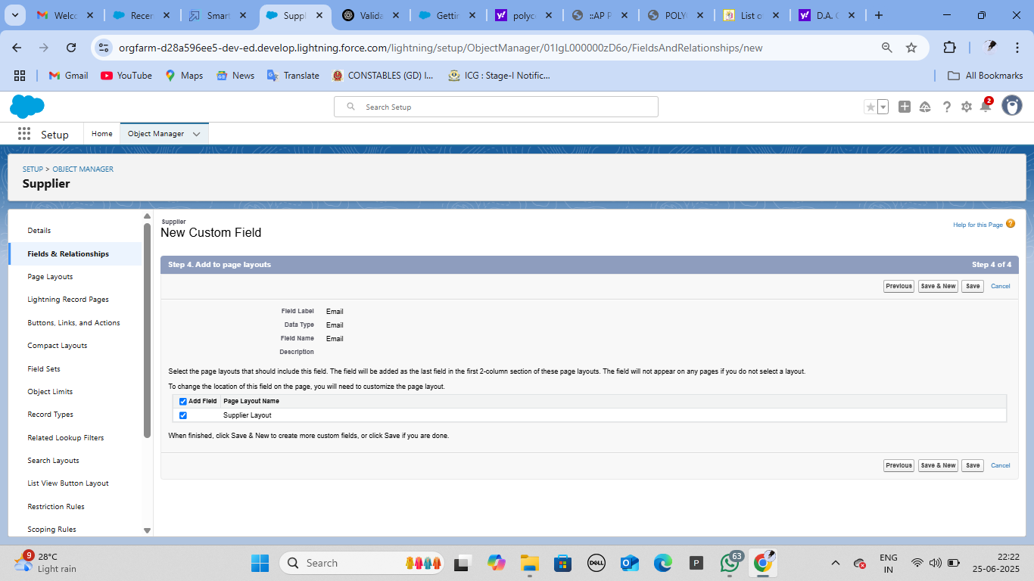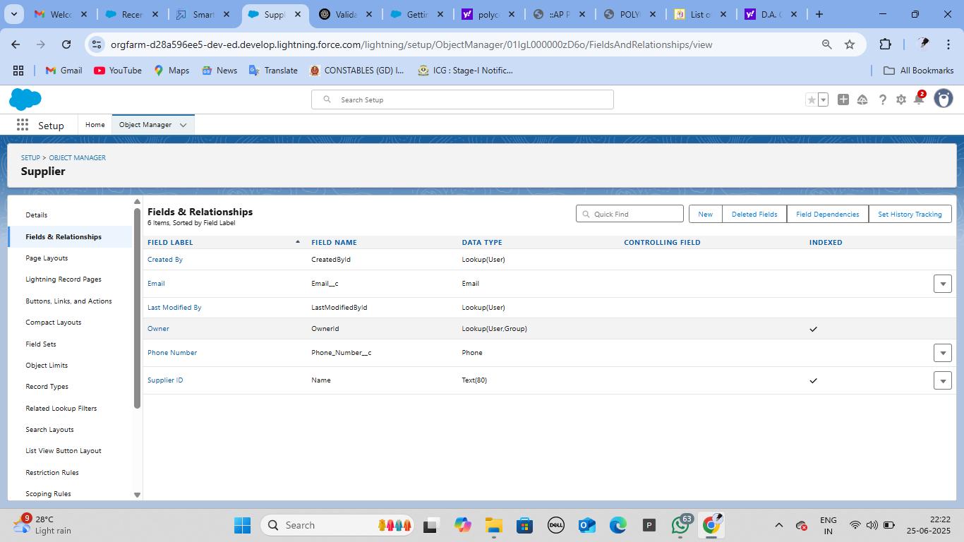

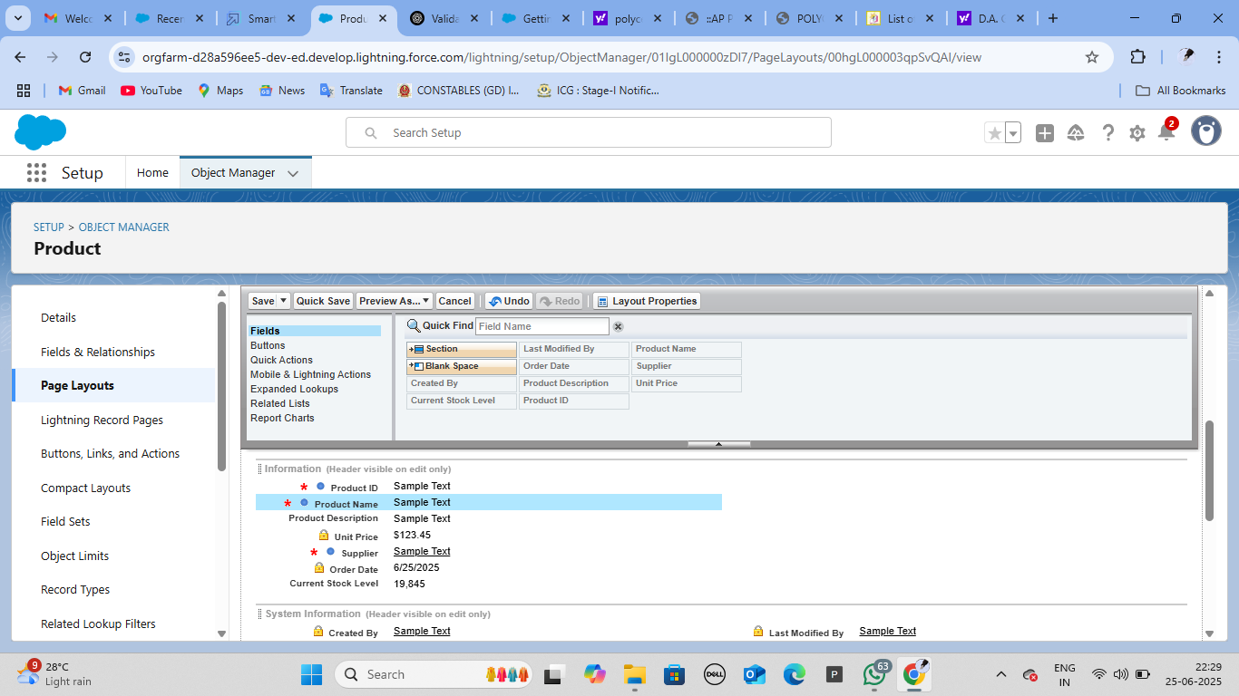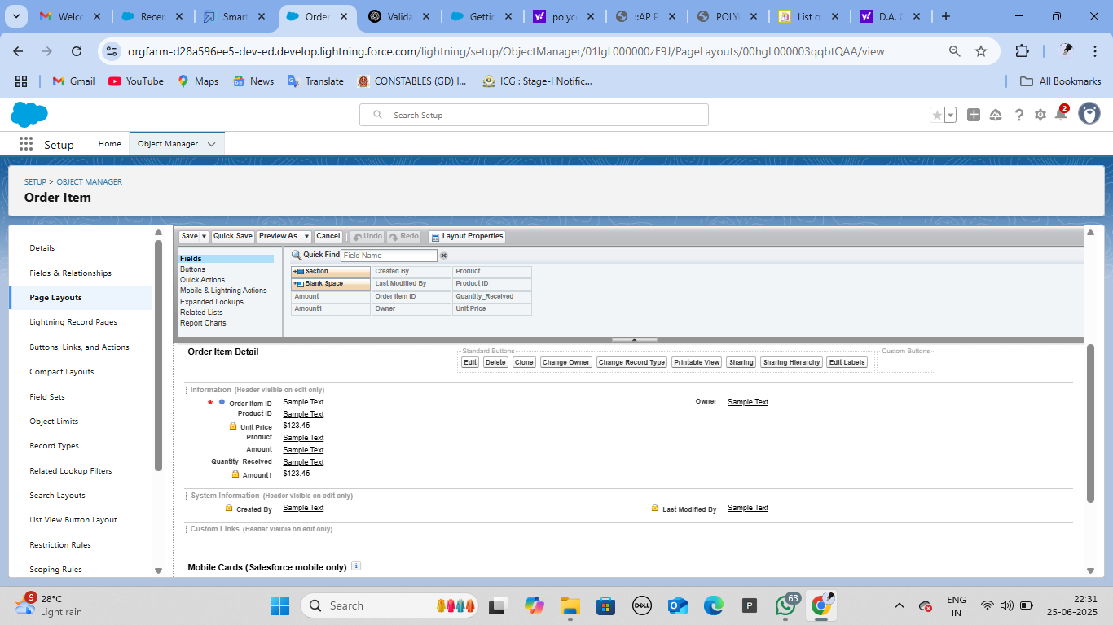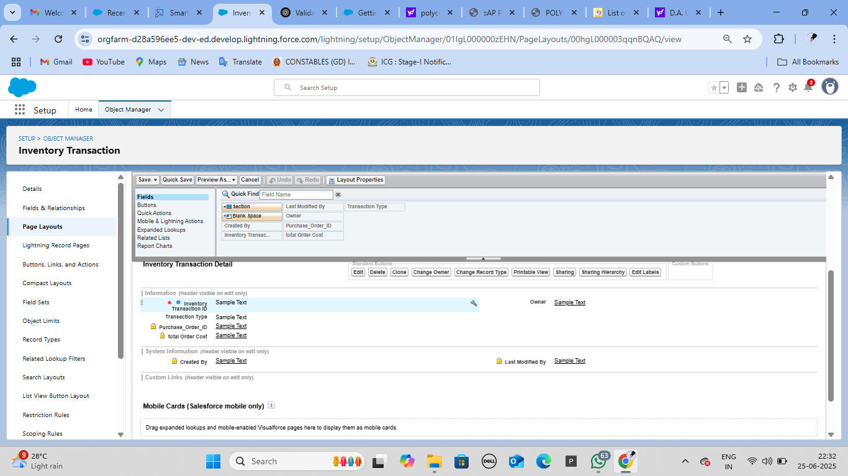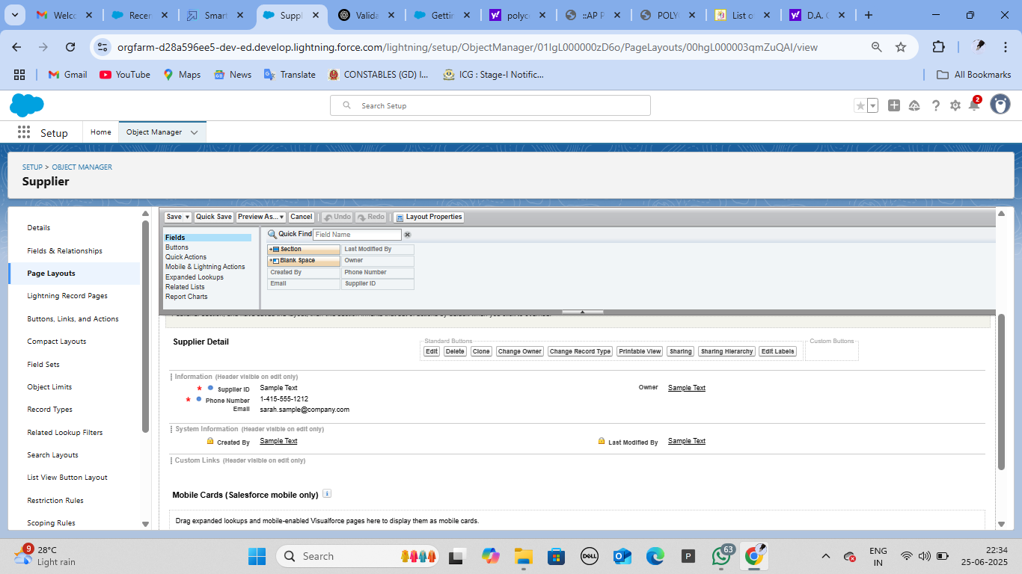



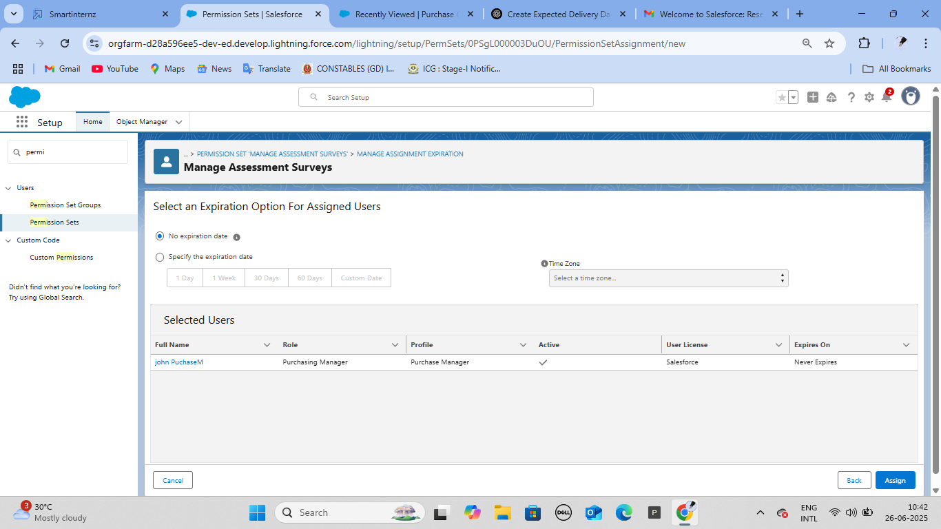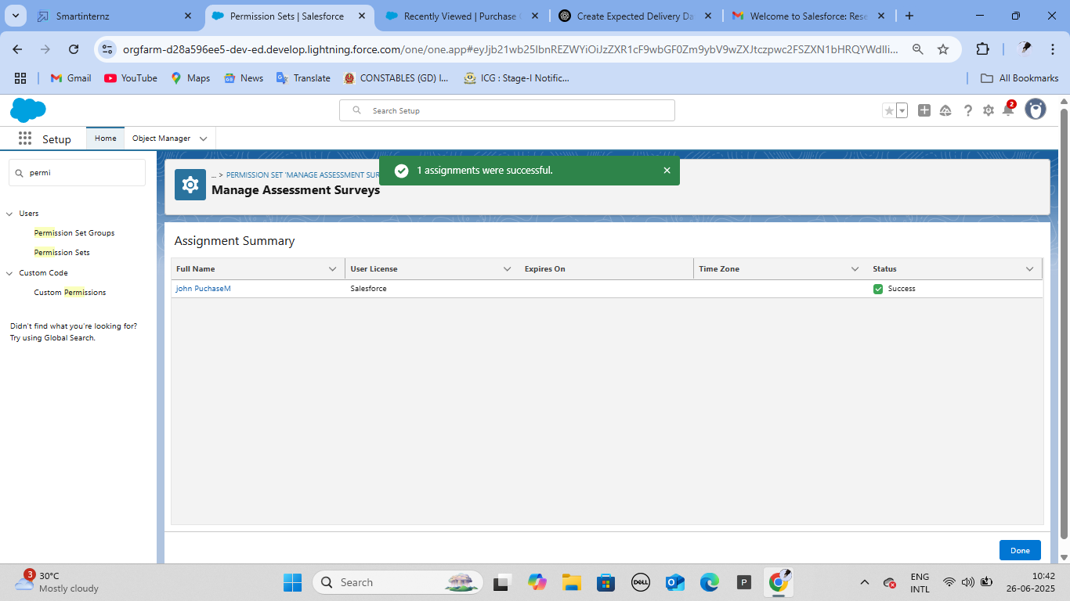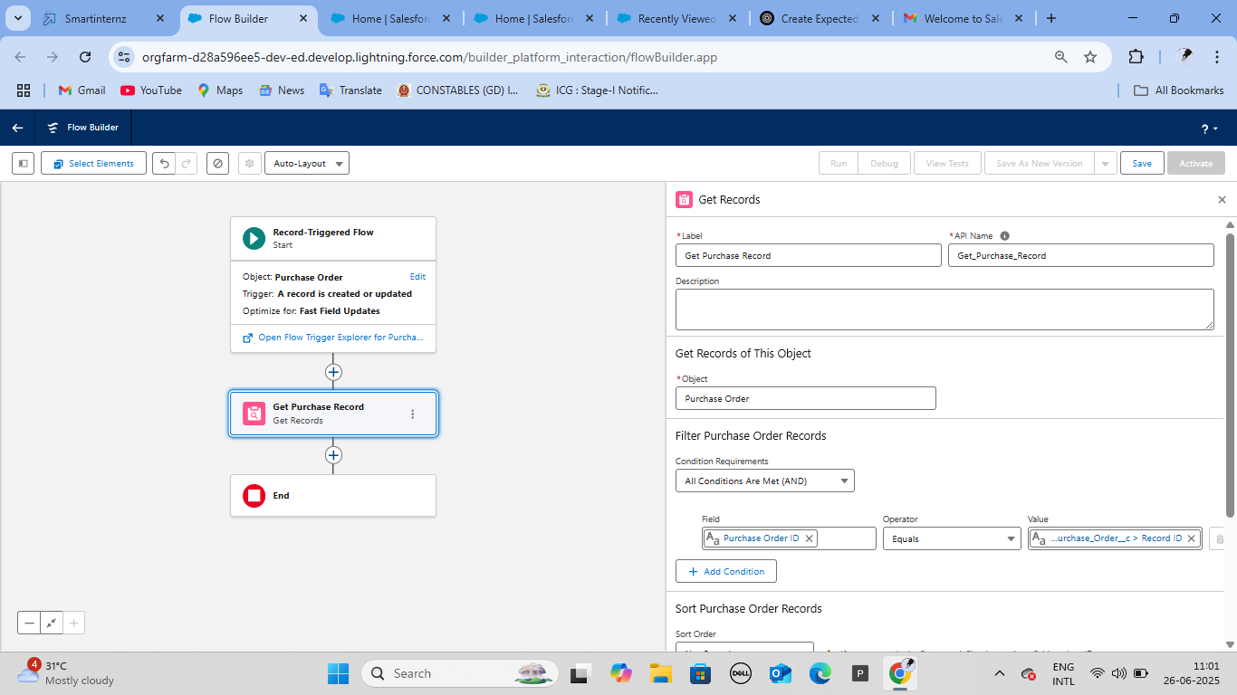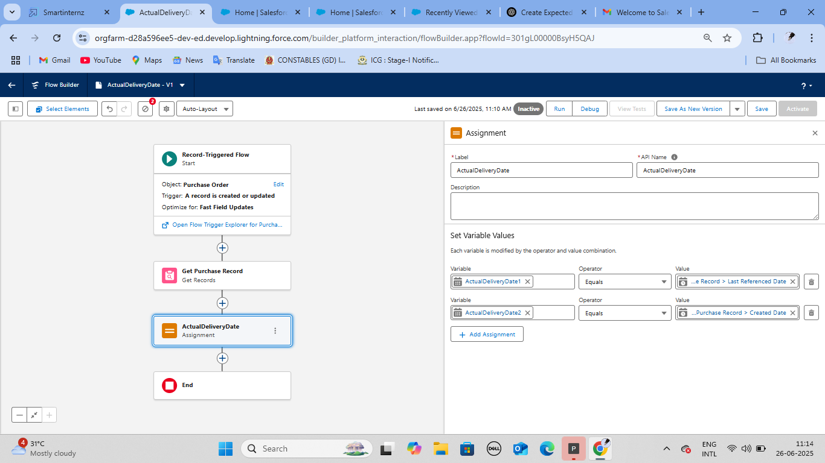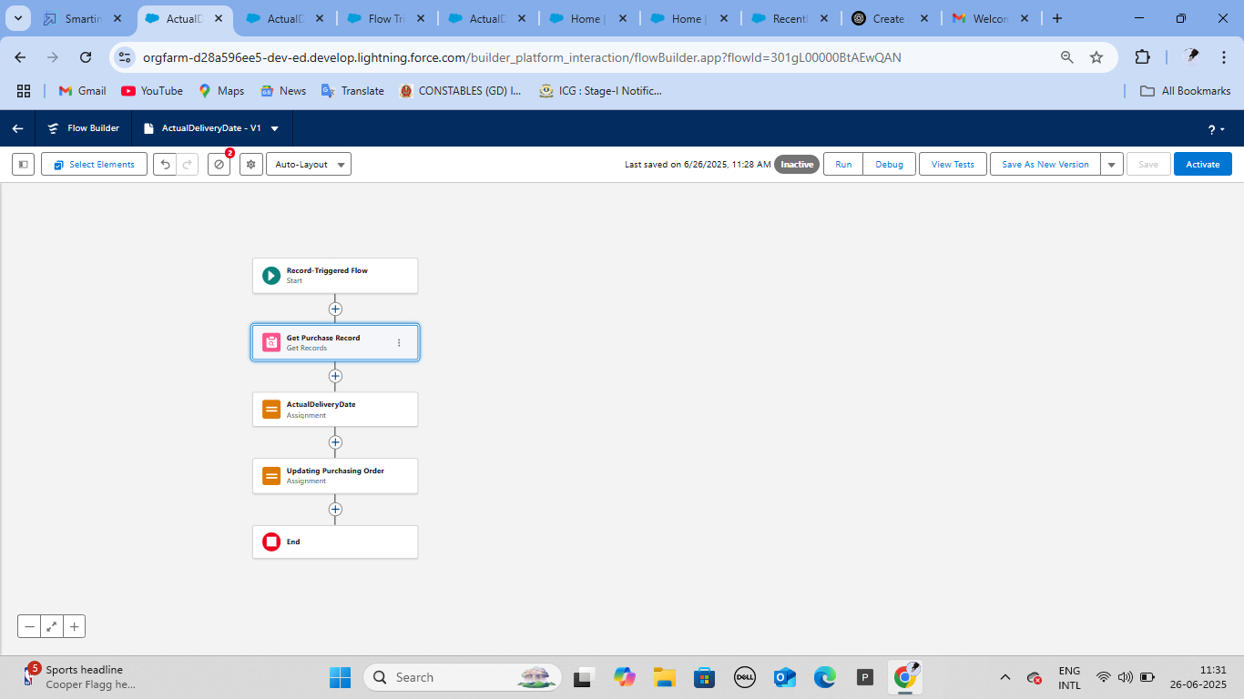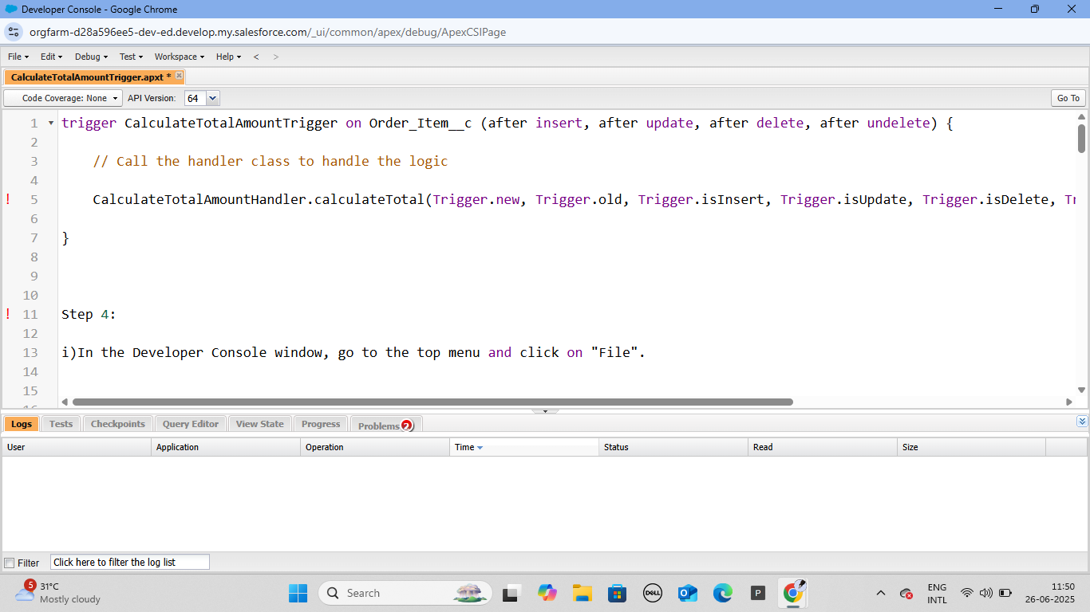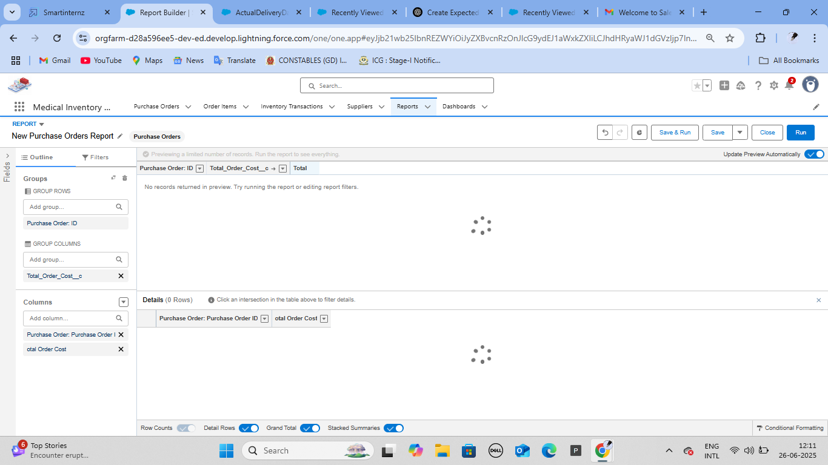

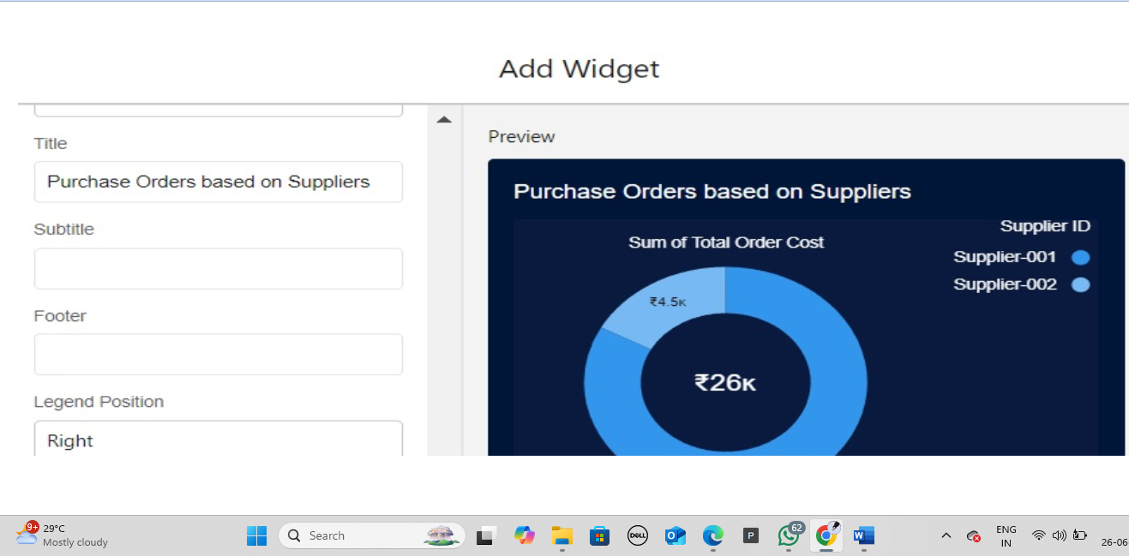

**FINAL OUT PUT:** 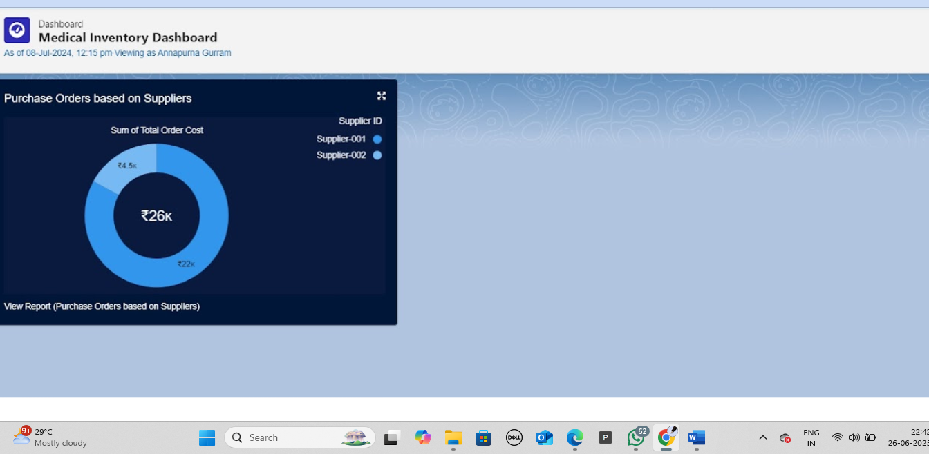

**7.ADVANTAGES & DISADVANTAGES :**

7.1Comparative Analysis: Before vs After Implementation :

| **Criteria** | **Before Implementation** | **After Implementation** |
| --- | --- | --- |
| **Inventory Tracking** | Manual using Excel or paper logs | Real-time, digital, automated via Salesforce |
| **Stock Alerts** | No notifications; required manual checking | Automated alerts for low stock and expirations |
| **Approval Workflow** | Paper-based or verbal approvals | System-driven with timestamped approvals |
| **Reporting** | Inconsistent and time-consuming | Auto-generated dashboards and exportable reports |
| **Audit Trail** | Not available or incomplete | Detailed activity logs with user-level tracking |
| **Scalability** | Difficult as volume grows | Easily scalable across multiple departments/locations |
| **User Access Control** | Shared access; low accountability | Role-based access with secure permissions |
| **Data Integrity** | Prone to errors | Validated and centralized data entries |

**7.2 SWOT Analysis**

The SWOT analysis offers a strategic view of the project’s internal strengths and weaknesses as well as external opportunities and threats.

**✅ Strengths**

* **Real-time tracking** of medical inventory across multiple departments.
* Built on **Salesforce**, ensuring high availability, security, and rapid deployment.
* Automated **email alerts**, **reporting**, and **workflow approvals** reduce manual effort.
* **Role-based access** improves accountability and audit compliance.
* Easy integration with **other hospital systems or APIs** in future.

**⚠️ Weaknesses**

* Dependent on **Salesforce licensing and customization**, which may involve costs.
* Users unfamiliar with cloud systems may require **basic training**.
* Limited **offline support** in case of no internet availability.

**🚀 Opportunities**

* Can be integrated with **supplier systems** for automated reordering.
* Potential to add **predictive analytics** (e.g., demand forecasting).
* Expandable into a **full Hospital Resource Planning (HRP)** suite.
* Can integrate with **IoT** for live usage tracking (e.g., smart medicine cabinets).

**⚡ Threats**

* Data privacy regulations (e.g., HIPAA) may require **additional compliance measures**.
* Resistance to adoption from users accustomed to manual processes.
* Downtime in Salesforce (though rare) can temporarily **disrupt access**.
* Cybersecurity threats demand ongoing **platform-level monitoring**.

This analysis highlights that while the project offers major operational improvements and future scalability, success will also depend on user training, security awareness, and proactive adoption planning.

**9.CONCLUSION :**

The Salesforce Medical Inventory Management System has been successfully designed and implemented to solve key challenges in the healthcare domain related to inventory tracking, management, and optimization. By digitizing and automating critical processes such as stock monitoring, expiry alerts, and approval workflows, the system has significantly reduced manual workload and the risk of human error.

This solution leverages the power of Salesforce's secure cloud environment, built-in automation tools, and scalability to deliver a platform that is not only robust and reliable but also user-friendly for medical professionals. Through features like real-time dashboards, audit logs, and automated notifications, it ensures timely decision-making and improves patient care by maintaining the availability of essential medical supplies.

Overall, the project meets its core objectives — enhancing operational efficiency, improving compliance, and supporting better resource planning in hospitals and clinics. With room for future expansion into predictive analytics, supplier integration, and multi-site deployment, the system serves as a scalable foundation for digital transformation in healthcare inventory management.

The project successfully met its planned objectives, offering a reliable, future-proof, and efficient inventory management system that aligns with the demanding environment of modern healthcare. It also lays the groundwork for continuous innovation—such as predictive analytics, automated restocking, and IoT-based real-time tracking—which can elevate hospital supply chains to new standards of efficiency and safety.

In summary, the Salesforce Medical Inventory Management System is not just a software application but a strategic tool that improves patient outcomes, reduces costs, and empowers healthcare institutions with smarter inventory decisions.

**THANK YOU**